Project Team: Cabarrus Health Alliance – Reduce P/PF Food Establishment Violations
Timeline: August 17-21, 2015

SOLVE
What is the Approach?
9. Team Members & Roles
10. Project Schedule
11a. Data and Information Collection
What are your Conclusions?
13. Improvement Hypotheses & Problem Solving Summary
What is the Gap?
1. Starting Point
2. Vision
3. Current State
What is the Goal for Improvement?
4. Goal or Target Condition
5. Customers & Beneficiaries
6. Benefit
7. Measures & Targets
8. Conditions

SOLVE
TRY, LEARN, INSTALL
Try Solutions; what did you learn?
14. Construct & Execute tests
15. Document Results
16. Analyze Results & Extract Learning
How will you make the new way happen?
- Plan Rollout & Execute
- Measures of Success
Understanding the Problems:
11b. Current and Future State Process Maps
12. Cause and Effect Diagram

_ SOLVE _
1. Starting Point
- What is the need (e.g. outcome) or gap that caused this project to be considered in the first place?
We want to reduce the number of Priority and Priority Foundation (P/PF) violations during routine food inspections in risk category IV establishments, therefore reducing the number of critical violation follow-ups (CV) and critical violation follow-up visits by the REHS. By determining the top five P/PF violations over the past four quarterly inspections, we will then determine the root cause of the violations (identify the gap on the establishment side) and determine how to effectively close the gap in the number one P/PF violation that has been documented. This will in turn decrease the risk of Foodborne Illness in establishments in Cabarrus County, NC.
b. Who is establishing the need?
Environmental Health Director, Supervisor, and Food & Lodging Staff
c. How is the need being measured and is it possible for this project to make an impact on that measure?
Digital Health Department (DHD) currently configures the numbers based on the number of risk category IV inspections and the number of P/PF violations that are marked during routine inspections. REHS’s receive an email notifying them of upcoming establishments that require CV follow-ups within the ten day required time frame. Baseline data is being gathered through a data dump based on the last four quarters on inspections. We hope to determine if there is a commonality of the root causes of these P/PF violations so that we may address these root causes to decrease the number of violations, which will in turn decrease the number of CV follow-ups and CV follow-up visits.
d. What data or analysis was used to establish that this project will make a key impact?
The number of P/PF violations for the past year identified by DHD, as well as the number of CV follow-ups and CV follow-up visits made by the REHS in the past year.
e. What scope (e.g. geographic, organization, customer) are you expected to impact?
This will affect the Cabarrus Health Alliance (CHA) Environmental Health Director, Food & Lodging Supervisor and 4 Food & Lodging Staff, residents and visitors who eat at food establishments located in Cabarrus County.
f. What conditions are being placed on this project? (Leadership requirements or boundaries)
- Time available for Food & Lodging Staff from regularly assigned duties
- Limited food establishment operators that have time to participate in either the event or training
- Lengthening the inspection process as it is now
- Adding more burden to the owner/operators of our establishments

2. Vision (What do you want to achieve in the long range (i.e. 10 years) and without any restrictions? Generate a picture or description of your ideal condition. How will it look for the customers, our team, and for the taxpayers/funding sources?)
- To maintain a decreased number of P/PF violations noted during routine inspections
- Decrease the risk of Foodborne Illness (FBI) to residents and visitors of Cabarrus County
- Continued/improved compliance with the NC Food Code Manual and improved sanitation scores

3. Current State (Description of how the process and organization is operating now; Quantitative if possible, always factual and based on observation)
Stakeholder | Description
Customers | - Disruptive to establishment’s day to day activities  - Potential additional expense(s) to correct any P/PF violations either immediately or within required 10 days  - Decrease revenue due to low/lower sanitation scores
Financial | - More CV follow-ups and follow-up visits are required due to P/PF violations (staff time)  - Increased travel time to make CV follow-up visits
Your Team | - Providing reactive solutions to current violations  - Following up on P/PF violations not corrected during inspections within 10 days
Society | - Higher potential risk for Foodborne Illness in Cabarrus County

4. Goal or Target Condition (What is the objective? Which piece of the gap are you addressing?)
TO: Decrease the number of P/PF violations in risk category IV establishments.

5. Customers and Beneficiaries (Who benefits from achieving the goal? What populations are targeted?)
FOR:
- CHA Environmental Health Food & Lodging Staff
- Owners/General Managers/Employees of food service establishments located in Cabarrus County
- Residents or visitors who eat at establishments in Cabarrus County

6. Benefit (What are the benefits from achieving the goal?)
SO THAT:
- Decrease the risk of FBI
- Improve quality of working relationships with owners/operators and increase on-going knowledge of P/PF violations for PIC

7. Measures and Targets (STANDARDS (How will you measure success; Measure and Target? What quantitatively will be achieved?)
Beneficiaries | What Measured | How Measured | Target
 |  |  | How Much | By When | Actual
Risk category IV Establishments | Number of P/PF violations | Data from DHD | 30% reduction in P/PF violations | 6 months post Kaizen Event

8. Conditions ((What process or team member requirements or limitations exist? What do you need to be successful?)
- Participation of CHA and Food & Lodging Owners/Operators
- Cannot change regulations
- Comply with regulation of P/PF not CDI (now points deducted, no longer general commented)

9. Team Members and Roles (Who is directly involved and How? Training Needs?)
Name | Role | Work process related interests / concerns | Project Expectations
Jim Osborne | Food & Lodging Supervisor | Track measurements of success/time spent on project.  Insure that NC Food Code Manual rules are maintained | Determine root cause of P/PF violations, decrease number of CV follow-ups and CV follow-up visits
Jennifer Hatley | QI Leader/Food & Lodging Staff | Lead Kaizen Event, conduct inspections, report on violations, conduct CV follow-ups and CV follow-up visits/Time away from normal work load | Insure direction of inspections/education is proactive vs. reactive
David Troutman | Environmental Health Director | Maintain departmental efficiency, develop departmental policies
Mary Barbee | Food & Lodging Staff | Conduct inspections, report on violations, conduct CV follow-ups and CV follow-up visits/Time away from normal work load
Carie Irving | Food & Lodging Staff | Conduct inspections, report on violations, conduct CV follow-ups and CV follow-up visits/Time away from normal work load
Daniel Squirewell | Food & Lodging Staff | Conduct inspections, report on violations, conduct CV follow-ups and CV follow-up visits/Time away from normal work load
Julia Patterson | Accreditation Director | Increase agency efficiency, ensure compliance with accreditation requirements | Successful QI project in EH
Emma Zelaya | CC4C Care Manager | Wildcard/Provide external prospective | Learn more about EH Food & Lodging Department and gain insight on services provided
Establishment Owner/operators  - Karen Barbee  - Karren Kwong  - Nikolas Katsanos  - Adam Hart | Stakeholder/Owner or manager of risk category IV establishment | Provide insight to root causes from customer prospective | Insure more compliance with NC Food Code Manual, decrease number of P/PF violations, increase working relationship with Food & Lodging Staff, increase sanitation scores, modify approach from reactive measures to proactive measures in establishment

Training Needs: Need to provide most team members with an overview of QI, explain Kaizen, and explain how the days of the events will go/what is expected from them

10. Project Schedule (How will you achieve the result? What is the basic approach, activities to go about solving the problem?)
BY:
- June-July: Collect data & information to understand the current process
- August 17-21, 2015 Perform Kaizen Event
  - Day 1: Focus the team; Understand the current state
  - Day 2: Continue to understand the current state; Evaluate and Solve the Problem
  - Day 3: Develop solutions (job aids); Test; Learn; Develop training material
  - Day 4: Continue to develop solutions; Test; Learn & train
  - Day 5: Pilot the new process; Learn; Measure results; Communicate results
- August: Install / Rollout

11a. Data and Information Collection (What will you collect? Who? When?)
WHAT | HOW  What is the data source?  What format is the data?  Data separated by categories or groups?  How accurate is the data? (seasonality, variation)  Who collect data from?  How much data needed, by category? How much time is needed to collect?  How will data be collected?  How can the data be analyzed? | WHO | WHEN
What data is needed to know the goal was achieved?
Numbers of P/PF violations for last 4 quarters | DHD, Access, Excel spreadsheets, separated by severity (P/PF), violation number, violation code, violation type | Jim/Jennifer/  Carie | Pre-Kaizen
Number of CV follow-ups and CV follow-up visits | DHD, Access, Excel spreadsheets | Jim/Jennifer/  Carie | Pre-Kaizen
What data is needed to get insight into the problem?
Numbers of P/PF violations for last 4 quarters | DHD, Access, Excel spreadsheets, separated by severity (P/PF), violation number, violation code, violation type | Jim/Jennifer/  Carie | Pre-Kaizen
Number of CV follow-ups and CV follow-up visits | DHD, Access, Excel spreadsheets | Jim/Jennifer/  Carie | Pre-Kaizen

11b. Observe and Document Current Process (Generate a Process Map)
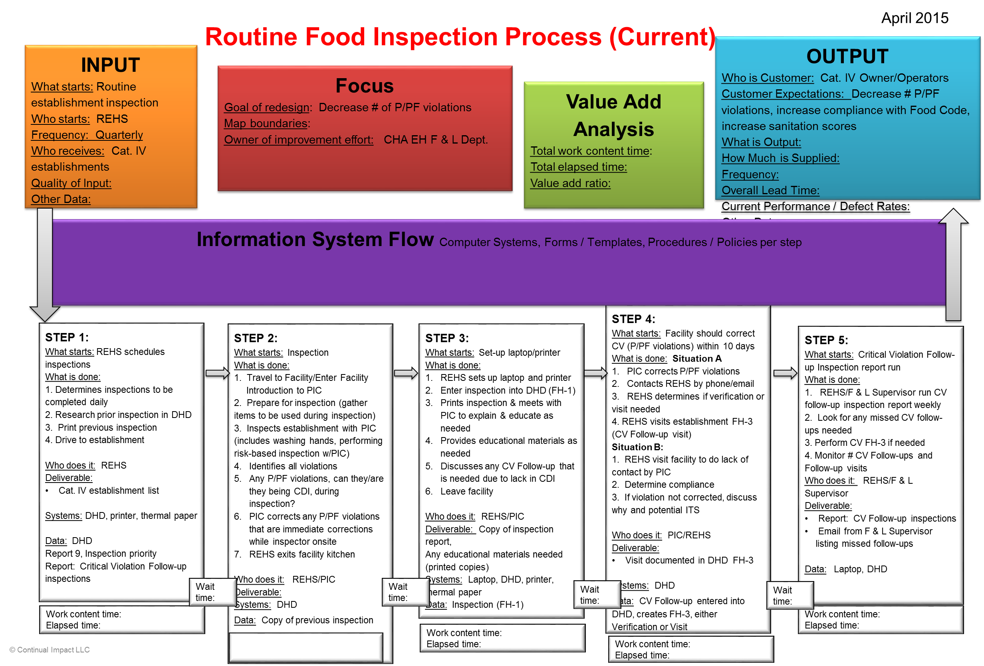

Prioritizing Issues / wastes:
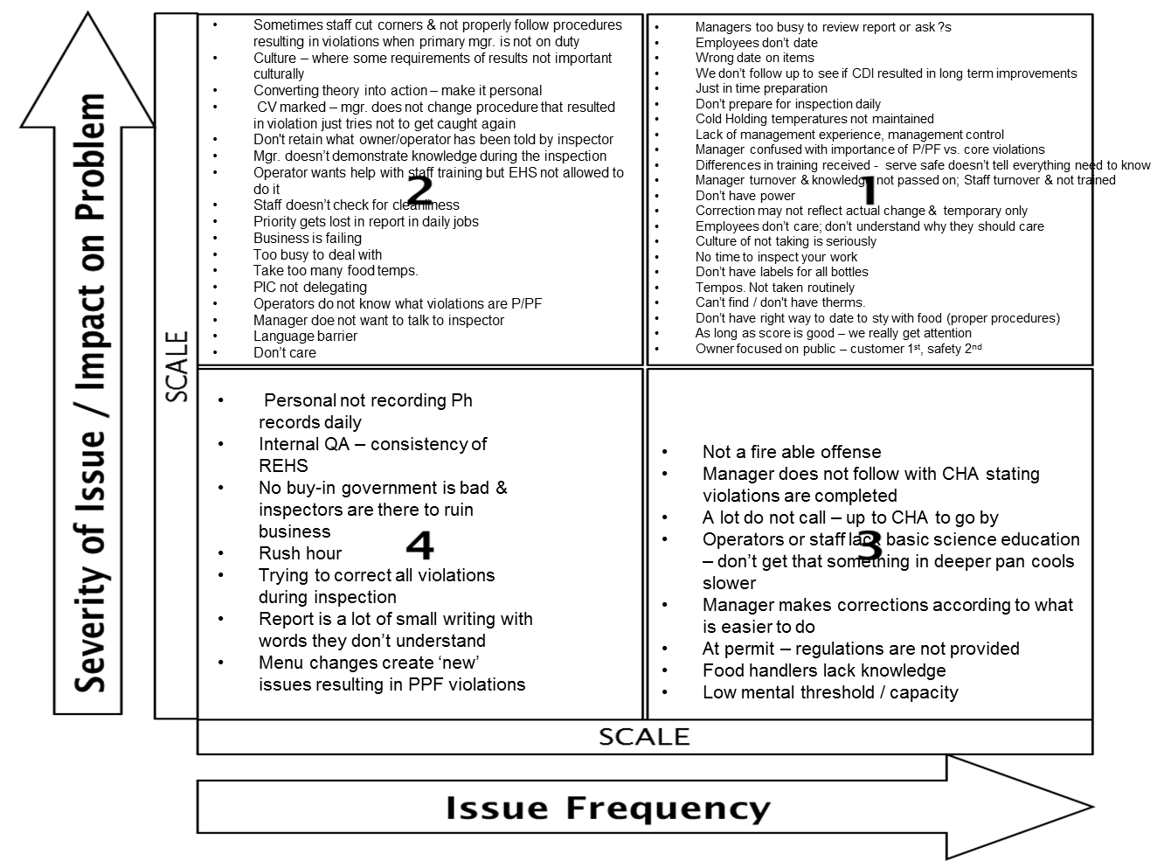

12. Conduct Cause and Effect Analysis (Priority issues and solutions from Cause and Effect Analysis)
Issues/Wastes | Root Causes
- Managers too busy to review report or ask ?s  - Employees don’t date & Wrong date on items  - We don’t follow up to see if CDI resulted in long term improvements  - Just in time preparation  - Don’t prepare for inspection daily  - Cold Holding temperatures not maintained  - Lack of management experience, management control  - Manager confused with importance of P/PF vs. core violations | See pics – zoom in to read

Root cause #1: Managers too busy to review report or ask ?s
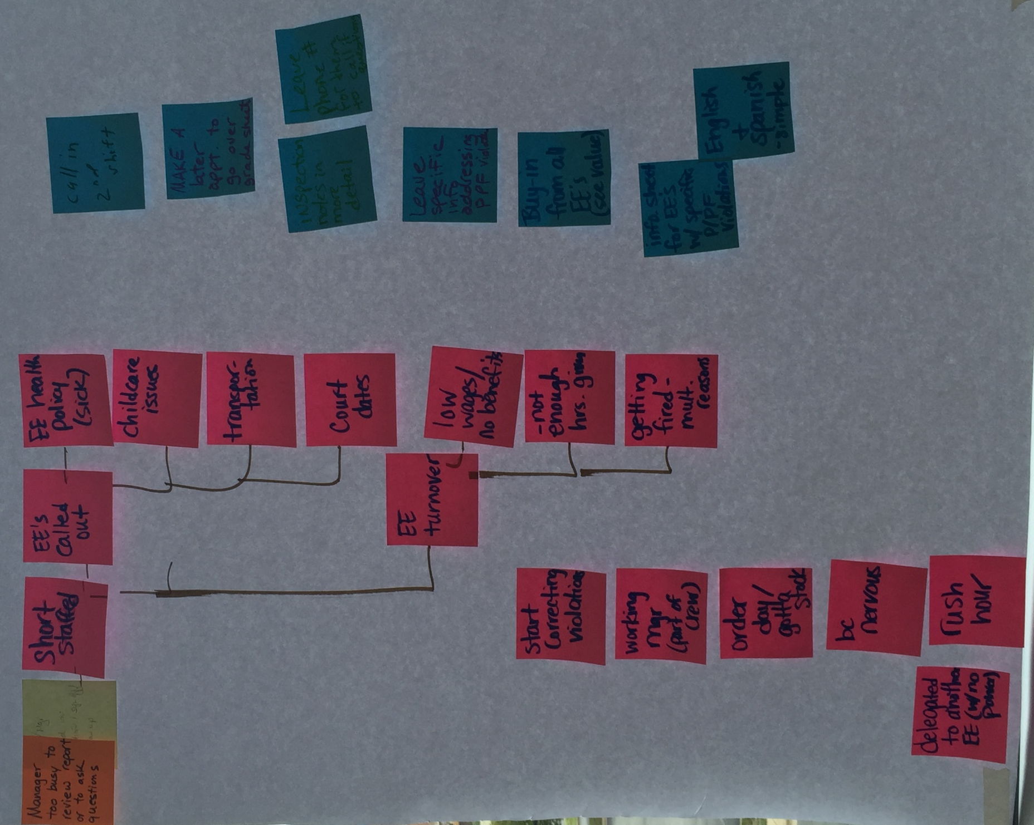

Root cause #2: Dating items
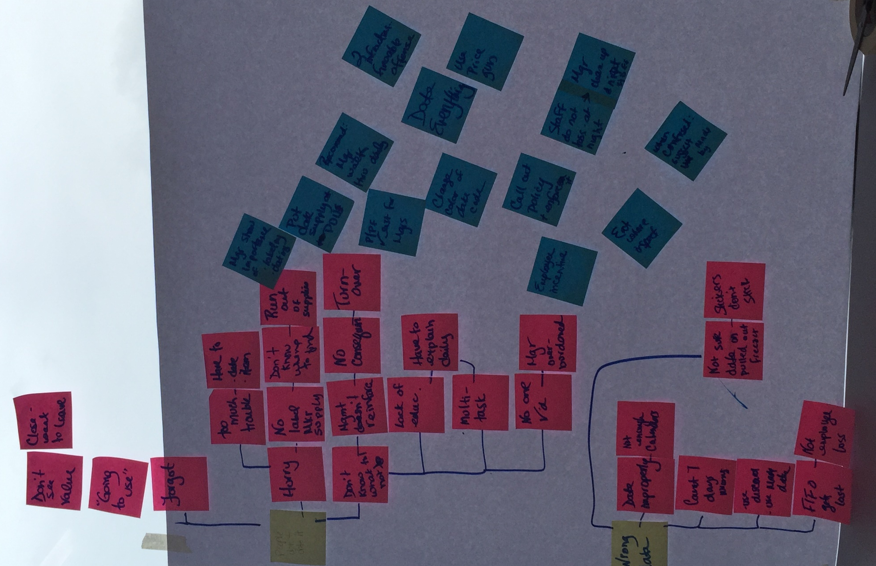

Root cause #3: We don’t follow up to see if CDI resulted in long term improvements
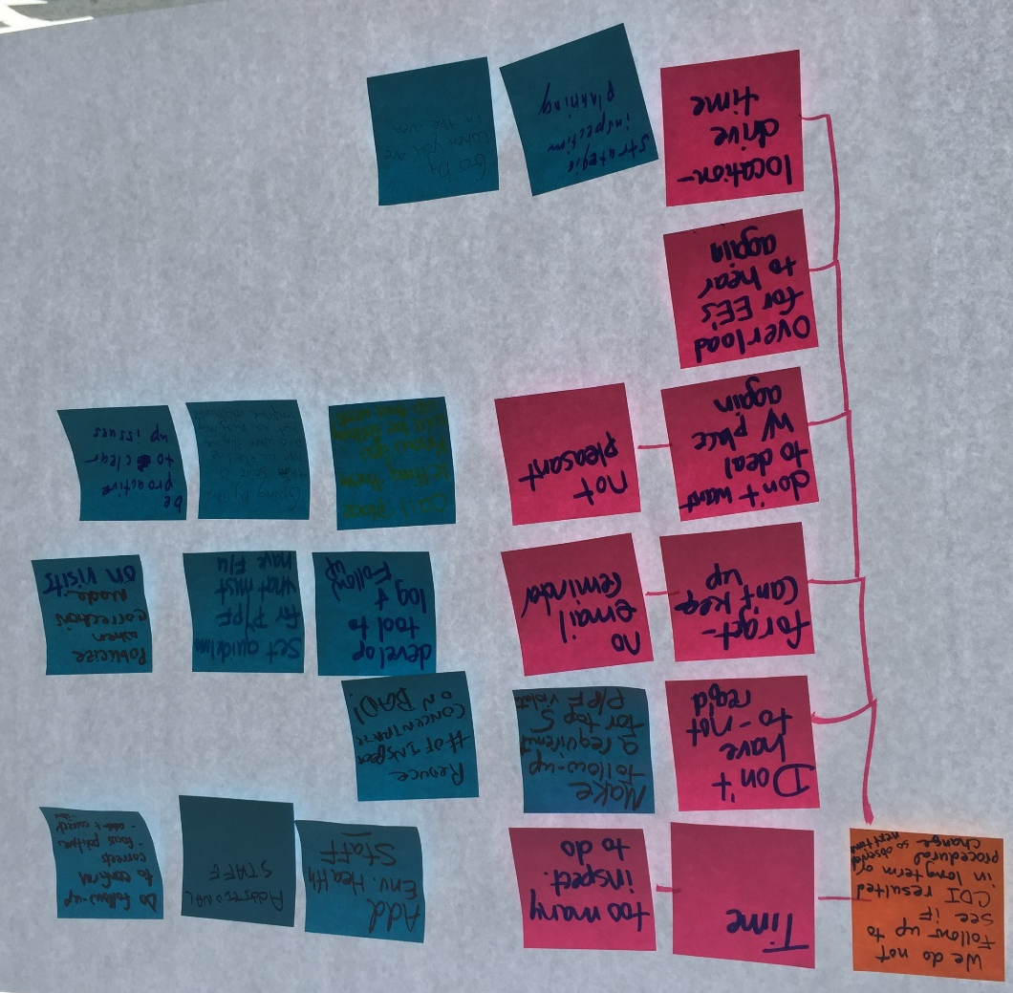

Root cause #4: Just in time preparation, Don’t prepare for inspection daily, Cold Holding temperatures not maintained

s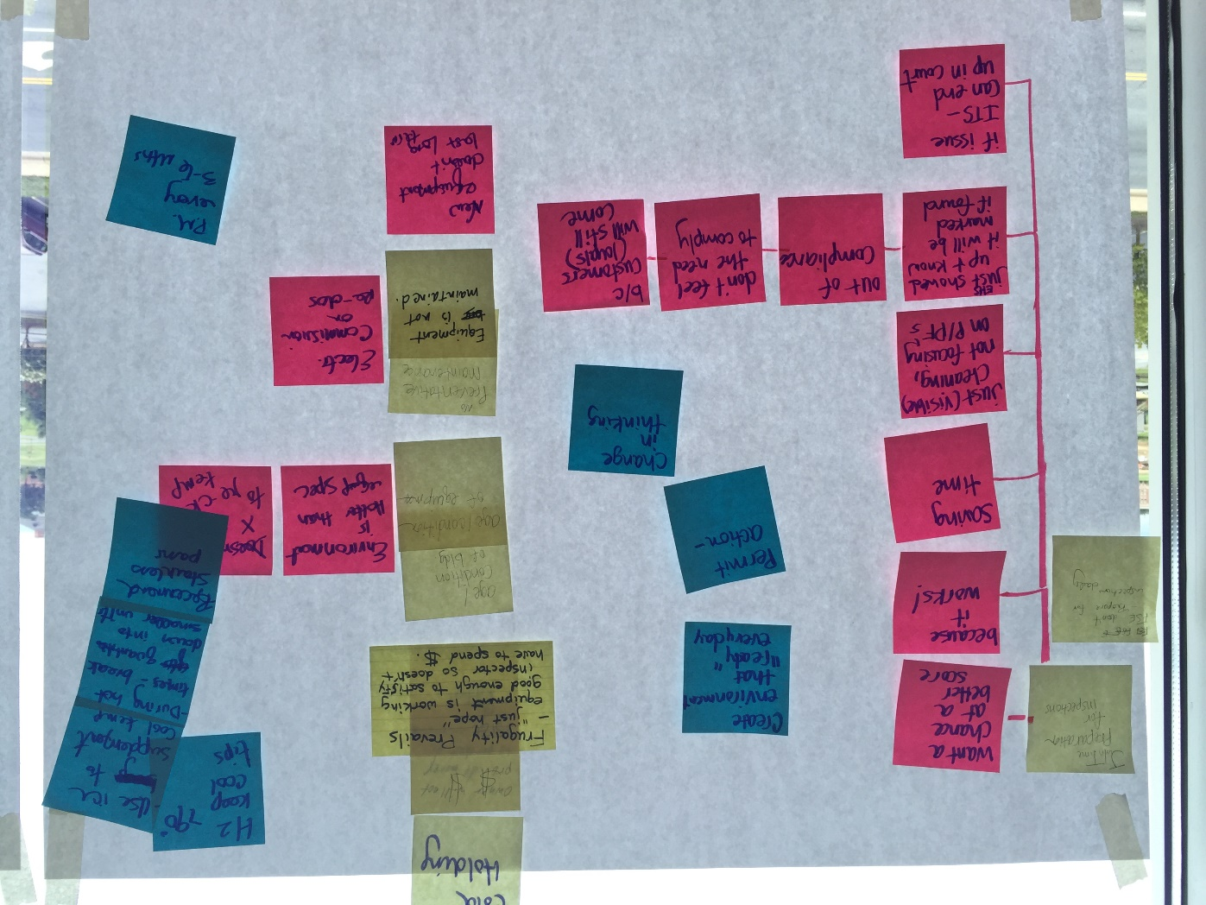
Prioritizing Solutions:
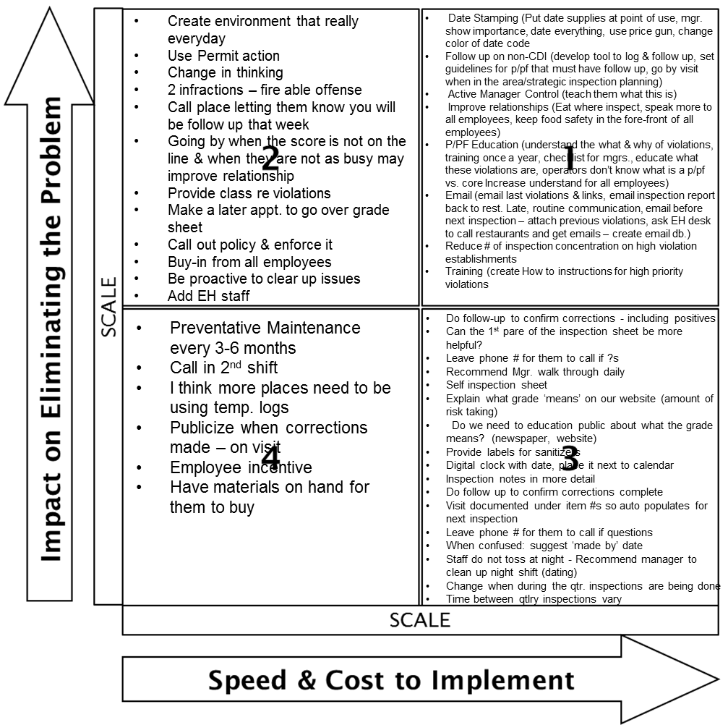

13. Improvement Hypothesis (Summary of potential means to achieve goal)
Issue | Improvement | Expected Results
Most frequently occurring violations  - hot & cold holding temperatures are not maintained  - Improper data marking & disposition  - Improper identification, storing, and using toxic substances  - Improper cleaning & sanitizing food contact surfaces | If we…provide How To instructions for all employees | Then…priority & priority foundation violations will decrease and food safety knowledge in all employees increases so that establishments are always in compliance (daily).
- Inconsistent follow up to see if CDI resulted in long term improvements | If we…develop a tool/document to log CDI violations and routinely follow up on CDI items and use strategic inspection planning | Then…we will see long term decrease of priority & priority foundation violations.
- Lack of management (PIC) time to review report or ask ?s, control, and understand the importance of P/PF vs. core violations  - Establishment employees preparing for inspections Just in time and not routinely | If we…engage with PIC and the food handlers during the inspection AND provide targeted P/PF education, Active Management Control responsibilities, AND routine knowledge (Email blasts, website, annual training) | Then…CHA & food establishment will have improved working relationships, PICs will take more ownership, and violations will decrease.

_ TRY _
14. Test Hypotheses (How will you test the potential solutions?)
Tests | How | When | Who | Successful if…
How to instructions by P/PF | Choose a follow Up visit on Qtr. 1 establishments with CDI P/PF violations | Thursday lunch | Mary, Daniel, Emma | Guideline handout feedback – Agree/Strong Agree  Verbal feedback provided
Email follow up | Choose a follow Up visit on Qtr. 1 establishments with CDI P/PF violations | Thursday lunch |  | Learn if establishment would like email
How to guidelines | Classroom test with Establishment owners | Thursday, Friday | Team | Guidelines are simple, printable, & accessible

15. Results: paste graph/table of actual trial performance

9 follow-ups visits
11 surveys completed
AMC: 2 Agree; 9 Strongly Agree
Use of 1 page education: 1 agree; 10 Strongly agree

_ LEARN _
16. Learning (For the trials, what worked and did not, why and what are you doing as a result? Is the result repeatable?)
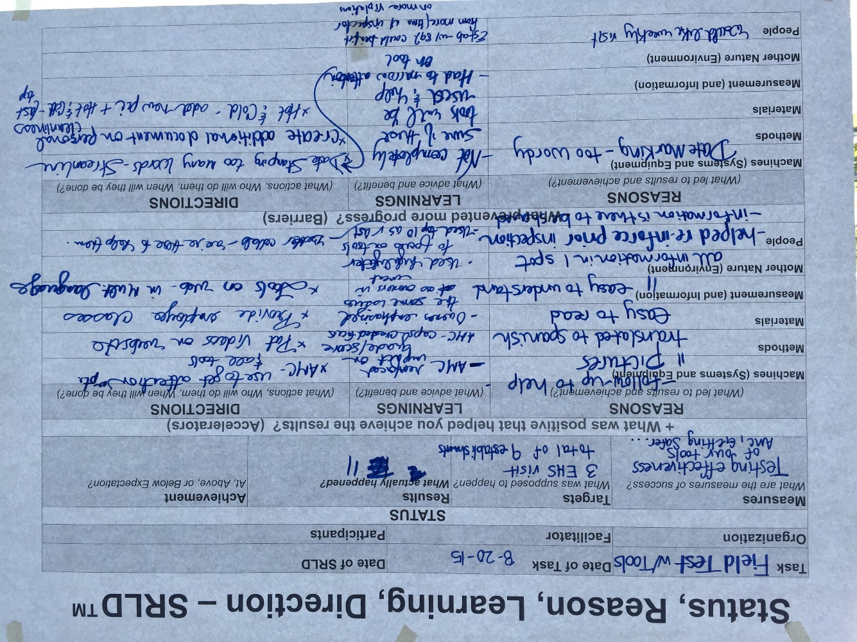

_ INSTALL _ 17. Installation Plan (Steps to operationalize the new process and make it stick. Attach new process map below.)
What | Recipient | Who will provide | By When
Begin using 1 page tools | Food Establishments | Team | August 24
Begin CV Follow visits | Food Establishments | Team | August 24
Complete all 1 page handouts (Spanish, Chinese, & as pdfs) | Food Establishments | Team | Sept 1
Update Website with tools & resources | Food Establishments | Team | Sept 1
Email Newsletters – Qtrly | Food Establishments | Team | October –November
Open food safety training | Food Establishments | Team | November

18. Measure Success
- Attach graph/table of installed performance measures
- Attach photo of current Continual Improvement System

