Solutions

Initial QI Initiative Questionnaire (May 2013)
- Based on a percentage 0 to 100%, what is your ability to develop, revise, and/or access department policies and procedures?
Answer: 50%

- Explain the process for developing, revising, and accessing a policy or procedure related to your area of work.
Answer: Unsure of a specific policy r/t departments. I believe the overall policy is for a draft to be written by the Health Director or designess, policy will be brought to staff for input, then a final draft will be reviewed by the Health Director and/or BOH (as applicable) for final approval.

- Is a QI initiative to create a process for developing, revising, and/or accessing department policies needed? If so, explain.
Answer: Yes. A standardized process for reviewing and updating policies is needed with specific timelines enforced (ie: policies will be reviewed, based on a schedule, annually). A standardized format for policy development is also needed.

QI Initiative Questionnaire After 6 months (October 2013)
- Based on a percentage 0 to 100%, what is your ability to develop, revise, and/or access department policies and procedures?
Answer: 95%
- Explain the process for developing a policy or procedure related to your area of work. If any, what are the changes/improvements that need to be made?
Answer: 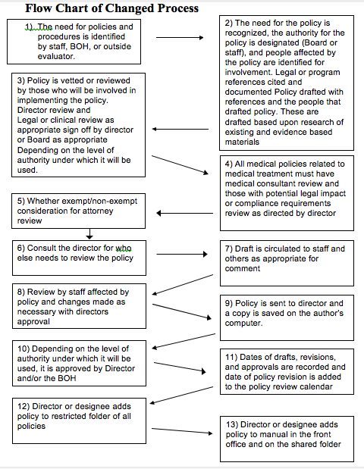
- Give example(s) of how the new process for developing, revising, and accessing department policies and procedures has benefited you.
Answer: Was able to check the immunization policy during immunization clinic and find the answer I needed to help a immunization patient.

