Project Team: Clackamas County Public Health Division
Timeline: February 24th-27th, 2014

SOLVE
What is the Approach?
9. Team Members & Roles
10. Project Schedule
11a. Data and Information Collection
What are your Conclusions?
13. Improvement Hypotheses & Problem Solving Summary
What is the Gap?
1. Starting Point
2. Vision
3. Current State
What is the Goal for Improvement?
4. Goal or Target Condition
5. Customers & Beneficiaries
6. Benefit
7. Measures & Targets
8. Conditions

SOLVE
TRY, LEARN, INSTALL
Try Solutions; what did you learn?
14. Construct & Execute Tests
15. Document Results
16. Analyze Results & Extract Learning
How will you make the new way happen?
17. Plan Rollout & Execution
18. Measures of Success
Understanding the Problems:
11b. Current and Future State Process Maps
12. Cause and Effect Diagram

SOLVE

1. Starting Point

- What is the need (e.g. outcome) or gap that caused this project to be considered in the first place?

Clackamas County Public Health Division has selected a QI project focused on improving its customer satisfaction process. While a formal policy was created with the involvement of the division’s QI Committee in January 2013, it has become apparent that the specific process of gathering client feedback across all of the division’s programs and services has not been fully addressed. As a result, it has become a challenge to adequately review the customer satisfaction process and make improvements.

- Who is establishing the need?

Clackamas County Public Health Division’s QI Committee and clients served by the division.

- How is the need being measured and is it possible for this project to make an impact on that measure?

Currently, it is estimated that 120 individuals per week visit the division’s administrative front office and 200 individuals per week visit the WIC clinic. These numbers do not include the field teams (inspectors, home visiting nurses) who will also solicit feedback from the individuals they serve (~320 visitors per week), along with Health Promotion staff who will solicit feedback from their community partners (estimates not available) and Communicable Disease calls/interactions with the community.

The measures of success for this project will be an increased number of completed feedback forms received and the number of improvements implemented based on feedback received (longer-term).

- What data or analysis was used to establish that this project will make a key impact?

The number of positive feedback, suggestions and complaints received were reviewed on a quarterly basis by the QI Committee. The committee is also currently measuring the number of feedback forms submitted by each of the division’s programs. Currently, 8-16 comment cards are received and reviewed each quarter; however, not enough feedback is being gathered from clients to make organizational improvements.

- What scope (e.g. geographic, organization, customer) are you expected to impact?

This project will be conducted across the division, which includes the following programs: front office/administrative staff, WIC, Vital Records, Environmental Health, Communicable Disease, Public Health Nursing (home visiting) and Health Promotion/Education.

- What conditions are being placed on this project?

- All programs follow the improved client feedback process
  - Use of adopted client feedback form
  - All programs and services must actively solicit feedback
- Feedback is initially reviewed monthly by the QI Committee and improvement activities are implemented based on feedback received at least quarterly
- Program managers respond to feedback immediately based on Client Feedback Policy

2. Vision (What do you want to achieve in the long range and without any restrictions? Generate a picture or description of your ideal condition. How will it look for the customers, our team, and for the taxpayers/funding sources?)
- Clients across all division’s programs and services are aware of and utilize the feedback mechanisms available to them in order to provide feedback that enables the division to improve program and services based on client feedback.

3. Current State (Description of how the process and organization is operating now; Quantitative if possible, always factual and based on observation)

Stakeholder | Description | How do you know?  (Data if available)
Customers | - Majority of clients are not aware of the division’s feedback process or are not provided easy ways to give feedback  - Clients do not quickly see the outcome of their feedback | 8-16 feedback forms returned each quarter.
Financial | - Currently an email function is available (not ideal)  - There may be an expense to make the committee card available via an online form | No feedback currently received through this mechanism
Program Teams | - Lack of engagement within many of the division’s programs and services (especially field staff)  - Currently lacks a meaningful review by the QI Committee | About half of programs distribute regularly; unable to make conclusions based on 6 comments/ quarter during committee review

4. Goal or Target Condition (What is the objective? Which piece of the gap are you addressing?)

TO: Increase the number of client feedback forms submitted across all of the Public Health Division's programs and services.

5. Customers and Beneficiaries (Who benefits from achieving the goal? What populations are targeted?)

- Client who visit Clackamas County Public Health Division
- QI Committee members (review feedback received)
- Public Health Managers (review, respond, and make informed decisions based on feedback received)
- All-Staff (implement QI projects based on community input)

6. Benefit (What are the benefits from achieving the goal?)

SO THAT:
- Clients receive quality services that meet their unique needs
- Clients know they have an avenue to provide feedback to the Public Health Division
- Clients feel confident their feedback will help shape improvements to the services provided by their local health department
- Staff gain knowledge and experience in implementing QI projects
- Staff are aware of the process to solicit feedback from the individuals they serve
- Division uses client feedback to prioritize and make improvements

7. Measures and Targets (What quantitatively will be achieved?)

Beneficiaries | What Measured | How Measured | Target
 |  |  | How Much | By When | Actual
All clients served by CCPHD | Increase the # of feedback forms received | The number of completed client feedback forms submitted | - A minimum of 128 per month across CCPHD (~5% of monthly contacts) | March 2014
Staff and PH Managers | Increase the # of improvements implemented based on feedback | The number of submitted feedback forms that result in process improvements being implemented within the division (longer-term goal) | - 3-5 process improvements implemented per year based on client feedback | December 2014

8. Conditions (What do you need to be successful?)

- Timely service delivery is maintained
- Consistent outreach and distribution is provided to all clients served
- Changes in customer satisfaction processes are communicated in advance with staff input
- addressed as soon as possible

9. Team Members and Roles (Who is directly involved and How?; Training Needs?)

Name | Role | Work process related interests / concerns | Project Expectations | Project, QI skills
Sherry Whitehead, Public Health Business Manager | Process Owner | Review of policy; serves in authority role and communicates back to management team | Active participation, available throughout entire week (February 24th-27th). | Lean Learner
Philip Mason, Policy Analyst | QI Leader | Facilitator of the process | Leads planning and implementation of Kaizen event; regularly available to Kaizen participants; communicates any proposed changes in process or policy back to PH Managers; leads efforts with QI Committee after completion of Kaizen event | Lean Facilitator, QI Coordinator
Sunny Lee,  Epidemiologist | Data Analyst | Assists in the analysis and preparations for review of quarterly feedback | Active participation; available throughout entire week (February 24th-27th). | Lean Facilitator
Marco Enciso, Office Specialist II | Participant | Supports implementation of project in Vital Stats | Active participation; available throughout entire week (February 24th-27th). | Lean Facilitator
Liz Baca,  Community Health Worker | Participant | Supports implementation of project in Public Health Nursing/CD Programs | Active participation; available throughout entire week (February 24th-27th). | Lean Learner
Cindy Pawlicki, WIC Nutrition Assistant | Participant | Supports implementation of project in WIC Program | Active participation; available throughout entire week (February 24th-27th). | Lean Learner
Charlie Gasbarra, EH Specialist II | Participant | Supports implementation of project in EH Program | Active participation; available throughout entire week (February 24th-27th). | Lean Learner
Kirsten Ingersoll, Community Engagement Coordinator | Participant | Supports implementation of project in Health Promotion Team | Active participation; available throughout entire week (February 24th-27th). | Lean Learner
Jamie Zentner,  Human Services Coordinator | Participant | Supports implementation of project in Health Promotion Team | Active participation; available throughout entire week (February 24th-27th). | Lean Learner
Pam Douglas, Admin. Assistant | Participant/Admin. Support | Logistics support for project and active participant in process | Assists in planning from January-February 2014; Active participation; available throughout entire week (February 24th-27th). | Lean Learner
Training Needs: ‘Making the Workflow’ Lean Activity on February 13th 2013.

10. Project Schedule (Activities to go about solving the problem)

- By: What is the approach to the problem?
- High level activities:
  - Day 1: Focus the team; Understand the current state; Evaluate and solve the problem
  - Day 2: Develop solutions (job aids); Test; Learn; Develop training materials
  - Day 3: Pilot the new process; Learn
  - Day 4: Learn; Measure results; Install (sustainability plan); Communicate results
- Draft the detailed project schedule (see “Clackamas Daily Agendas” PowerPoint)

11a. Data and Information Collection(What will you collect? Who? When?)

WHAT | WHO | WHEN
Information from staff on current processes | All Kaizen team members

11b. Observe and Document Current Process(Generate a Process Map)

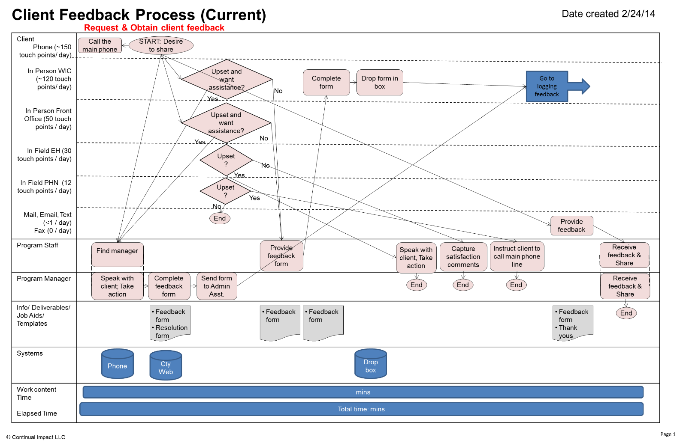

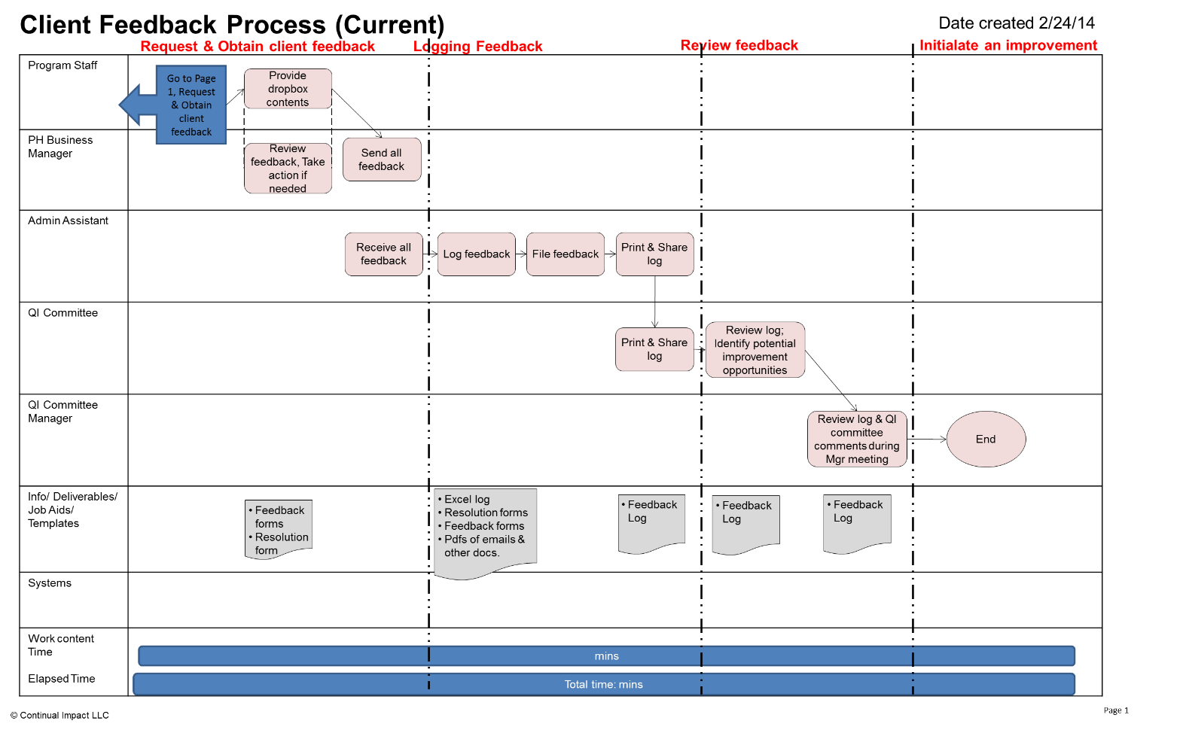

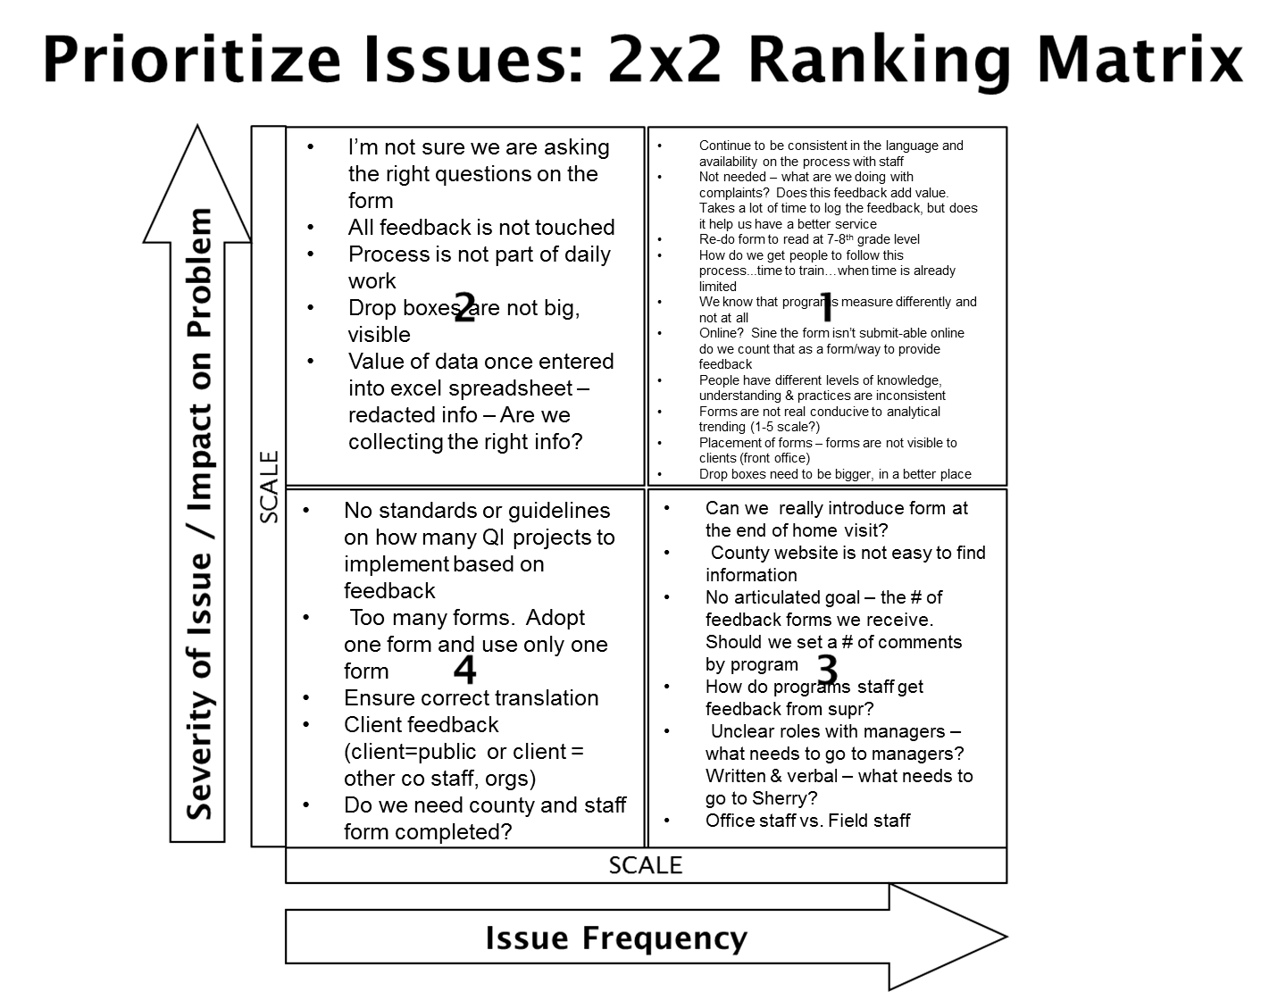

12. Conduct Cause and Effect Analysis (Priority issues and solutions from Cause and Effect Analysis)

Category | Issues/Wastes | Root Causes | Solutions or Additional CI Methods to use | Speed and Cost to Implement
MEASURES | -info. collected is not helpful for trending | N/A | Improve form to only contain helpful info. desired to be tracked/ reviewed | Easy, low cost
PEOPLE | -not all staff know the process  -programs and implementing the process differently | Form is not accessible | Clarify the process through creation of training materials and job aids | Easy, low cost
ENVIRONMENT | -physical locations need improvement | Form is not assessable | Improve drop-boxes, add client feedback online submission option at WIC kiosk | Easy, low cost
MATERIALS | -form is not easy to complete (long, wordy, etc.)  -multiple versions of survey | Form is not easy | Edit the form to make it shorter and an easier reading comprehension | Easy, low cost
SYSTEMS/EQUIP | -no online submission | N/A | Create survey monkey submission form on all PH webpages | Easy, low cost

13. Improvement Hypothesis(Summary of potential means to achieve goal)

Issue | Improvement | Expected Results
Form not accessible | Update website for easy access | Increased # of completed client feedback
Lack of understanding of the process thereby gathering client feedback is not a priority | Standardize the client feedback process (Create, test, train, and continually improve) | Staff process, role, and process expectations  Increased # of completed client feedback
Form is not easy to use | Use on-line survey form  Add form to restaurant packet  Add form link to email contact  Establish office kiosk | Increased # of completed client feedback

TRY

14. Test Hypotheses(How will you test the potential solutions?)

Material | What’s still needed | When | Who | Successful if…
One-page cheat sheet for staff to know how to request & record feedback received | -Additional staff feedback  -Change the word ‘cheat’ to ‘training’  -Colored papered  -Laminated for all staff members | By Day 4 | Charlie | Will be used by all staff members
Client Feedback Policy | -Add info. about staff receiving a personnel issue about a colleague | By Day 4 | Pam & Kirsten | Will gain approval by PH managers
Order new dropboxes | -Need to be purchased | Two Weeks | Pam & Cynthia | Dropboxes are visible to clients and used
Hard-copy feedback form | -Form needs to be created  -Translated to Spanish | Two Weeks | S Sunny & Liz | Client and staff are accessing and providing feedback
Online feedback form | -Inputted and formatted into Survey Monkey  -Translated to Spanish | Two Weeks | Sunny & Liz | Client and staff are accessing and providing feedback

Open Action Items:

Material | Learning: Why? | Direction: Actions to be taken
One-page cheat sheet for staff to know how to request & record feedback received |  | -Additional staff/feedback?  -Change the word ‘cheat’ to ‘training’  -Colored papered  -Laminated for all staff members
Client Feedback Policy | -Leave the policy overarching in scope | -seek approval of the policy  -allow time for an additional review and update at April 3rd 2014 QI Committee meeting to evaluate policy based on implementation of the new process.  -Add info. about staff receiving a personnel issue about a colleague
Client Feedback Guidelines | -5 pages that give general guidelines for each step of the client feedback process | -Guidelines need to be reviewed by Client Feedback Lean RPI Team members and feedback sent back to Pam D. no later than March 6th 2014.  -Each program/team can develop more specific guidelines that expands on their unique interactions within this process
Dropboxes & Form Containers | -Draft created of signage for storage of feedback forms next to dropbox and feedback was seeked from front office staff members | -WIC is purchasing the drop box and located in waiting room at main office and satellite clinics  -Front office will purchase a larger dropbox  -Laminated label for the dropboxes and feedback form containers that complement each other
Hard-copy feedback form |  | -Hard copy form will be developed once online feedback for is finalized  -Feedback/testing needed by March 12th
Online feedback form |  | --Sunny will lead revision process and needs feedback/testing finalized by March 12th  -Feedback needed on program/ services titles within online form  -Revise question on “What was the reason for your interaction…”  -Remove #s from matrix  -Review “Who helped you?” question  -What to do about date of service? (to be determined by PH Admin Assistant & Epi.)
Public Health Feedback webpage | -Consensus of the RPI team was that they liked having a Feedback page | -Review and update to fix content typos by next Tuesday (March 4th)  -All Public Health webpages should have a link to this webpage  -All email signatures should link to this webpage  -All forms should provide link to this webpage  -Need page to be approved
Email signature instructions & example |  | -Review and update to fix content typos by next Tuesday (March 4th)  -Will be sent to PH staff March 12th

15. Results:

Due to being a 4 day event it was too soon to collect any trial information regarding the new process. Below is the future state map that was created.

LEARN

16. Learning (For the trials, what worked and did not, why and what are you doing as a result? Is the result repeatable?)

Task | Date of Task | Date of SRLD
Client Feedback Kaizen Event | February 24th-27th, 2014 | 03/13/2014
Organization | Facilitator | Participants
Clackamas County Public Health Division | Philip Mason | Sherry Whitehead, Business Manager  Sunny Lee, Epidemiologist  Marco Enciso, Support Staff  Liz Baca, Community Health Worker  Cindy Pawlicki, WIC Nutritionist  Charlie Gasbarra, EH Specialist  Kirsten Ingersoll, HEAL Coordinator  Jamie Zentner, SBHC Coordinator  Pam Douglas, Admin. Assistant

STATUS
Measures  What are the measures of success? | Targets  What was supposed to happen? | Results  What actually happened? | Achievement  At, Above, or Below Expectation?
Increase the # of feedback forms received | - A minimum of 128 per month across CCPHD (~5% of monthly contacts) | Too early… | TBD
Increase the # of improvements implemented based on feedback | - 3-5 process improvements implemented per year based on client feedback | Too early… | TBD

+ What was positive that helped you achieve the results? (Accelerators)
REASONS  (What led to results and achievement?) | LEARNINGS  (What advice and benefit?) | DIRECTIONS  (What actions, Who will do them, When will they be done?)
Machines (Systems and Equipment)
+Use of preparation checklist  +Heavy on slides day 1…less the rest of the week | +Room set-up the workday before event  +Stayed in the same room all week | +Hope to spend less time on background information on day 1 and move more quickly to using tools
Methods
+Use of Kaizen tools to structure event was helpful and flowed well throughout the week  +Report out was a great success  +CIS is in motion & trainings have already been started and the new process has begun | +Probably should have practiced more using all of the tools  +Having each team member describe a part of the event was really rewarding as a facilitator | +Train others within department on use of kaizen tools as part of our ongoing Lean efforts  +Each team now wants a CIS in their work areas to structure staff huddles and discuss team projects
Materials
+Team was able to develop a lot more than anticipated  +Gained buy-in to edit policy to support the future process | +Putting out a policy is different than creating a process in support of the policy | +Use Tell-Do-Show concept for training staff moving forward
Measurement (and Information)
+Had very clear measures of success prior to event | +Major benefit having the measures well defined and clear for team members | +When challenges arise throughout any event, attempt to bring the group back to the goal of the project
Mother Nature (Environment)
N/A
People
+Leadership support was very high  +Very strong team with a variety of styles  +Process owner changed from manager to support staff member (strong buy-in and commitment from this person)  +Vacation was helpful to recharge batteries | +Having leadership come to the event mid-way through the event and give feedback on the future state process was helpful to give team members confidence in their work

- What prevented more progress? (Barriers)
REASONS  (What led to results and achievement?) | LEARNINGS  (What advice and benefit?) | DIRECTIONS  (What actions, Who will do them, When will they be done?)
Machines (Systems and Equipment)
N/A
Methods
-No team members was too attached to the current process | -I think this both helped and hurt the team. Team members weren’t too set on a specific way of doing things but needed motivation to think creatively when designing the future state
Materials
-The event ended with a lot of drafted materials due to 4 day event | -Not as much time for testing and development of new materials as were probably desired but everyone took on the new process and rolled with it | -Find a way to get more hours for future events  -Develop a strong action items list and sustainability plan (CIS)
Measurement (and Information)
-Even with clear measures of success there was still challenges with measures occasionally | -Expect measures and goals to sometimes be challenged
Mother Nature (Environment)
-4 day event
-Difficult to keep everyone in the room
People
-Often a challenge to move team members along and out of the details throughout the event  -Struggle to keep team members energy up towards the end of the event  -At times lost sight that the customer/client is the focal point of the process | -Keep swimming. The event is a lot of information and feels overwhelming for team members at times. In the end it is worth it! | -Involve more key stakeholders (such as clients) in the process

INSTALL

17. Installation Plan (Steps to operationalize the new process and make it stick. Attach new process map below.)

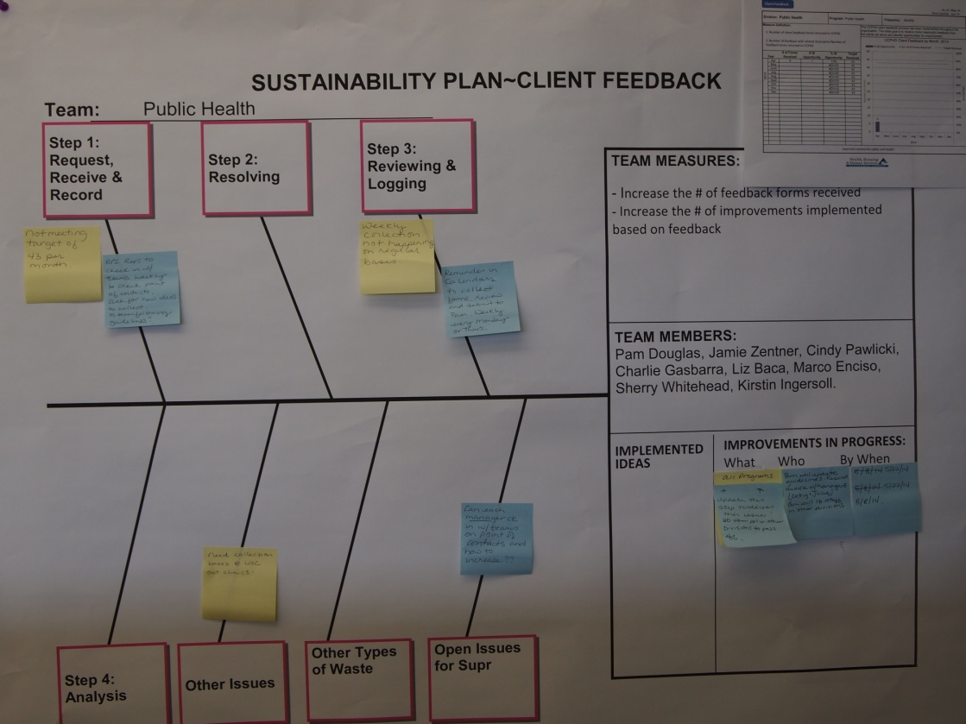

Next Steps:
- Staff trainings on the new process scheduled for the month of March
- Go Live date set for April 1st
- Monthly huddles at each QI Committee meeting with Client Feedback Team to discuss issues and open action items
- Regular staff communication will be needed

18. Measure Success

