Project: Breastfeeding Support
Health Services
May 2013

PLAN
Identify an Opportunity and
Plan for Improvement

1. Getting Started

Breastfeeding women were not getting the support they needed in a timely fashion. By the time we called them, they had already given up on breastfeeding.

AIM #1
Because support in the first 3 days post delivery has been demonstrated to have positive impact on continued breastfeeding, the number of first time breastfeeding women* in Missoula county who receive a call from a CLC from PHHV within 3 days of delivery will increase from 23% to 40% by September 30, 2013
*Later amended to include all discharged mothers
AIM #2
Breastfeeding phone is optimally utilized to support Breastfeeding women in Missoula County as evidenced by a 20% increase in the use of the phone by breastfeeding women.

Lessons learned:
We should have identified an AIM related to number of women visited.
We went from 15 clients opened (3 months) to 73 clients opened (3 months).....a 486% improvement

2. Assemble the Team
The team consisted of Maternal Child Health staff, the MCH Nursing supervisor and the Division Director.
3. Examine the Current Approach
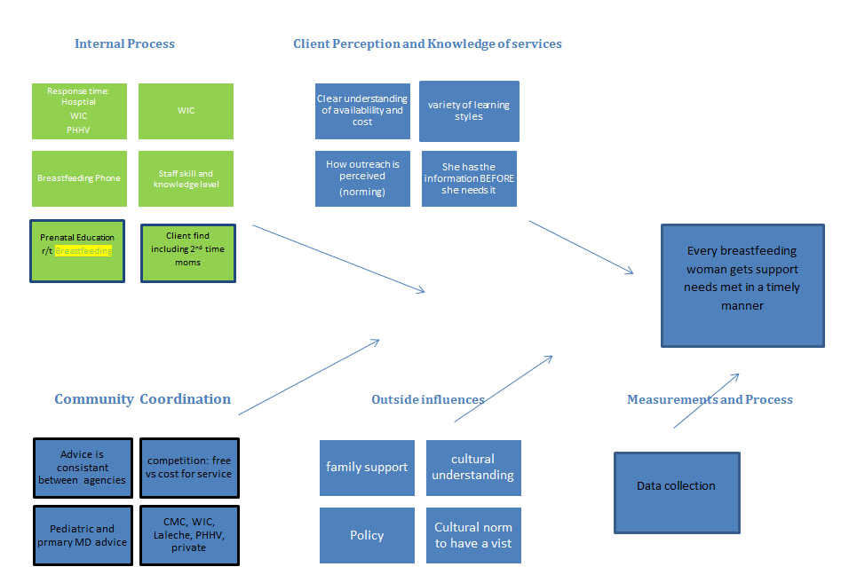

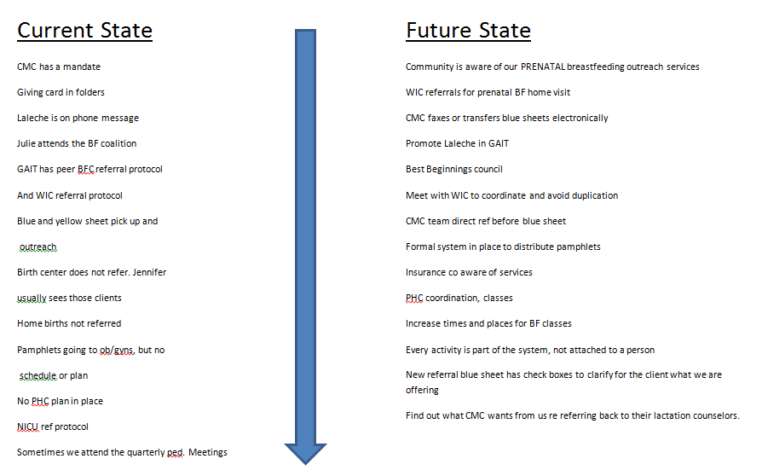

4. Identify Potential Solutions
- Promote services to pregnant women through OB/GYNs, Community Medical Center registration process, WIC, and other places pregnant women access services
- Increase the frequency of days we pick up referrals
- Make the team smaller, more efficient and more effective
- Standardize the assessment and intervention offered by the outreach staff
- Create a business card
- Use the breastfeeding hotline cell phone to make the outreach calls to assure that the client will have easy access if she wishes to return the call
- Increase reliability of staff responsible for answering the hotline
- Staff the hotline ONLY with CLC staff
- Leave a more clear, consistent message with new mothers that normalizes the outreach call
- Provide wrap-around care by increasing our coordination efforts with our community partners
- Improve staff availability for same day home visits for mothers who request them
- Call ALL new mothers, not just first time mothers

5. Develop an Improvement Theory

One of the staff from the newly formed five member Newborn Team of Certified Lactation Counselors picks up the referrals from CMC daily. They make outreach calls on our BF hotline phone offering feeding support to all new mothers. A standardized message is left when appropriate. Same-day visits are available when mothers respond to outreach call or call the breastfeeding phone.

DO
Test the Theory for Improvement

6. Test the Theory
We implemented some our improvements one at time in order to isolate what did and did not have positive impact on client services.
We created a small team of CLCs to provide outreach and to staff the phone daily. This team picked up of hospital referrals of newly discharged mothers daily. Using our cell phone to do outreach increased mothers’ ability to return our call easily, and we were available for same-day home visits even weeks or months later.
When leaving a message, we emphasized that the visits would not cost them money and were offered to all new mothers in our community.
We did a focused outreach project to the clients registering at the hospital prenatally to see if we could provide prenatal support and education. We had such poor results it was decided that this was not a good use of staff time.
We distributed breastfeeding support hotline business cards and information about our service wherever pregnant women might be accessing services and developed an ongoing outreach plan.
We improved our coordination with WIC, LaLeche, pediatricians, OB/GYNs and other community partners.

CHECK
Use Data to Study Results
of the Test

7. Check the Results
AIM #1
Because support in the first 3 days post delivery has been demonstrated to have positive impact on continued breastfeeding, the number of first time breastfeeding women in Missoula county who receive a call from a CLC from PHHV within 3 days of delivery will increase from 23% to 40% by September 30, 2013.
Result: increased to 44%
AIM #2
Breastfeeding phone is optimally utilized to support breastfeeding women in Missoula County as evidenced by a 20% increase in the use of the phone by breastfeeding women.
Result: 420% increase

We should have identified an AIM related to number of women visited, (lesson learned).
We went from 15 clients opened (3 months) to 73 clients opened (3 months) a 486% improvement.

Additional unplanned results:
We identified that we need to talk to ALL new mothers. Previous initiation of breastfeeding did not mean moms do not want or need support with subsequent new babies.
We went from 0% second time breastfeeding moms opened (3 months) to 12% second time breastfeeding moms clients opened (3 months).

Unplanned results:
Many mothers have saved the breastfeeding number and called months later with additional questions.

Mothers have started telling each other about the service, resulting in more calls from new mothers based on word of mouth referrals.

Pediatricians and OB/GYNs have started referring pregnant women and new mothers to our services.

Prior to the QI project, MCH staff felt positive about the idea of providing breastfeeding support for women, but disliked carrying the phone (it never rang) and universally disliked breastfeeding outreach job duty. By assuring that they are self-selected, well trained, and supported to devote the time needed to do the job well, the five members of the Newborn Team view this as their FAVORITE job duty and love providing this service!
But most importantly, NEW MOTHERS love this! The response from the mothers we visit has been amazing.

ACT
Standardize the Improvement and Establish Future Plans

8. Standardize the Improvement
or Develop New Theory
We adopted the theory and have maintained our results. The Newborn Team continues to look for ways to further improve and strengthen our ability to be responsive to the needs of breastfeeding women in our community.

9. Establish Future Plans

We have developed a form that can be faxed from the hospital and are working toward not having to drive to the hopsital to pick up referrals.

Completed May 2014

TEAM MEMBERS:

Vicki Dundas. MCH Supervisor, Jenn Kirscher, PHN, Julie Johnson, PHN, Kate Siegrist, Director of Helath Services, Annette VanDomelen, SW.

TEAM CHAMPION:
Managers who supported the project

Vicki Dundas, and Kate Siegrist,

