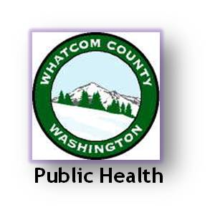
TB QUALITY IMPROVEMENT STORY BOARD 5/12/15

 | WHATCOM COUNTY HEALTH DEPARTMENT | QI Team: Alice Simmons, TB Program Supervisor
 | 509 Girard Street, Bellingham, WA, 98266 | Ann Lund, TB Program PHN
 | (360) 676-6724 | Connie Kelley, Immunization Program PHN
 | 75 employees, serving a | German Gonzalez, MD & CD & EPI Division Manager
 | population of 201,140 | Susan Sloan, Performance Management Specialist
 |  | 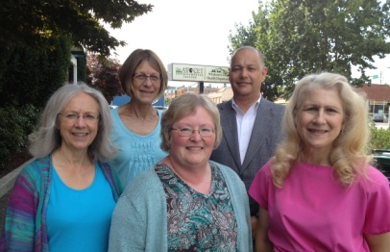
qi project: | TB Rate Improvement Project

DEFINITIONS:
LTBI: Latent Tuberculosis (TB) Infection
NNPHI: National Network of Public Health Institutes
COPPHI: Community of Practice Public Health Improvement

PLAN: Identify an Opportunity and Plan for Improvement

1. Getting Started
Our overall goal for the project was to increase the percentage of high-risk clients with latent TB infection (LTBI) who start treatment by 5 percent.

2. Assemble the Team
Our team included TB supervisory staff, a TB nurse, an Immunization program nurse, and our QI facilitator. We also received QI coaching support from NNPHI as part of a $10,000 COPPHI grant.

3. Examine the Current Approach
We focused our efforts on researching guidelines used by other LHJ’s in screening clients for TB and how to improve our effectiveness in getting high-risk LTBI clients into treatment.
AIM STATEMENTS:
Quality Planning: By July 31, 2013, the TB-. Project will increase the percentage of high-risk LTBI clients who are screened by staff from 75 percent to 90 percent (thus reducing numbers of low-risk clients screened)
Quality Improvement: By July 31, 2013, the TB-. Project will increase the percentage of high-risk LTBI clients who start treatment by 5 percent.

The team conducted a detailed
review of
the VFC

      - The team identified that most TB programs have clear guidelines as to the types of clients who are screened. Our lack of guidelines drove up program expenses (WCHD carried the $311.47 cost per screening) and reduced staff resources to focus on high-risk LTBI clients—those most at risk for becoming a positive TB case.
- The team also identified inadequate staff one-on-one contact with clients as the root cause as to why clients do not start treatment.

4. Identify Potential Solutions
The following potential changes were identified:
- Create and implement LTBI Guidelines for the screening, treatment, and outside referral of clients originally referred to WCHD. Decrease WCHD low-risk client screening.
- Improve communication and follow-up with high-risk LTBI clients who are recommended treatment.

5. Develop an Improvement Theory
- If we reduce the number of low-risk LTBI screenings done then we will save staff resources that can be focused on obtaining better LTBI client outcomes.
- If we are more effective in convincing high-risk LTBI clients to start and complete treatment, we will see lower rates of active TB in our county.

DO: Test the Theory

6. Test the Theory
- Guidelines were created.
- The QI team and Health Officer created TB education resources (including revision of TB web page) that enabled the providers to more easily screen low-risk cases. In order to track our work, an MS Excel database was developed using standardized, objective methods.

CHECK: Use Data to Study Results

7. Study the Results
- Screening Savings: During the period 2013-2014, a total of 151 fewer TB clients were seen by staff than in the baseline year (2010). This resulted in a savings in screening costs of $47,032 over two years.
- ROI: For every $1 invested in the quality planning component, WCHD realized a return of $1.31 after costs.
- Improved Treatment Starts: From 2010-2014, there was a 25% increase in the percentage of Class 2 clients who started treatment for LTBI. (2010=48%(n=95), 2014=60%(n=30)
- Improved Treatment Completion: From 2010-2014, there was an 11.9% increase in the percentage of Class 2 clients who completed treatment. (2010=74%(n=70), 2014=82.8%(n=24)

ACT: Standardize the Improvement and Establish Future Plans

8. Standardize the Improvement
The TB QI Initiative is fully incorporated into the TB program.

9. Establish Future Plans
The LTBI screening process continues to be refined as needed.

