***Things to think about when creating the current state map:***

**Capture every step – “The document is printed (1) then stapled (2) and attached to the spreadsheet (3) and then filed which means creating a label and placing it in the file. Things to think about – do other people need to get the file? If so, is it in a central location, are multiple copies made?”**

**Capture every information flow – “The e-mail is sent to the manager (1) then the manager sends it to the Office Director (2) and then it is sent to the Office of the Assistant Secretary (3).”**

**For each step, note:**

* Who:
* What:
* When:
* Where:
* Why:
* How:

**Common Symbols:** It is more important to document the process in detail, than to get the symbol right. A written description will work!

[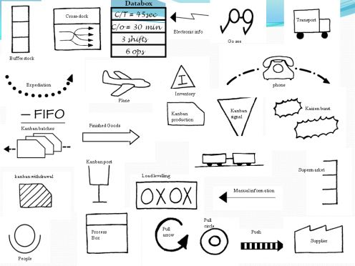](http://leanman.hubpages.com/slide/How-to-Create-a-Value-Stream-Map/3411676)

Data Box

Trans-port

Supplier

Customer

Electronic Info.

[](http://leanman.hubpages.com/slide/How-to-Create-a-Value-Stream-Map/3411676)

Kaizen Bursts

Batch Process

Process

Box

**How many, how much and how long?**

* ***Pace:*** *what is the demand; what is the time frame?*
* ***Processing time (or touch time):*** *how long does it take for each transaction (the actual work involved)?*
* ***Cycle time (or wait time):*** *how often a product is completed by a process? How long does it take to go through all of the work elements before repeating them?*
* ***Incoming Yield (%):*** *How often is it done right the first time?*
* ***Number of forms or documents*** *(1) to be filled in; (2) how many times repeated and how long from start to finish?*
* ***Number of staff*** *in each step?*
* ***Inventory:*** *how many transactions? How many forms? How many pieces?*
* ***Queue:*** *waiting time for the form or service to enter the next process step.*

***Things to think about when creating the future state:***

**Value Added -- From the customer’s perspective:**

***Value Added***

* Any activity that increases the market form or function of the product or service. (These are things the customer is willing to pay for.)

***Non-Value Added***

* Any activity that does not add market form or function or is not necessary. (These activities should be eliminated, simplified, reduced, or integrated.)

***Non-Value Added by necessary*** (e.g., grant or regulatory requirement)

Possible Areas of Waste in the Process

**Processing**



**Search Time**



**Correction**



**Transportation**



**Underutilized People**



**Inventory**

**Wait Time**

**Space**



**Complexity**

**Examples of Types of Waste**

* **Malfunction junctions** (where do errors happen?)
* **Bottlenecks** (where does the process hang-up? What hangs the process up?)
* **Wait times** (What are they and why (e.g., batch processes, missing information)
* **Re-works** (when do things have to be re-done, corrected)

***What Might Help?***

* Would a visual cue help? (schedules, control charts etc.,)
* Where can we remove non-value added steps?
* Where can we decrease the time-frames?
* What work could benefit from redesign?