**Total Responses to Desired Intervention Question: Pre Test**

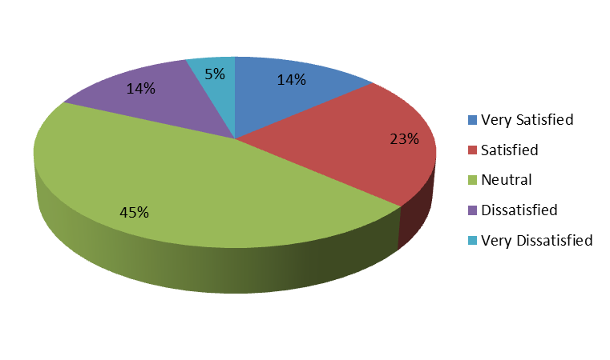

Figure 1

**Total Responses to Desired Intervention Question: Post Test**

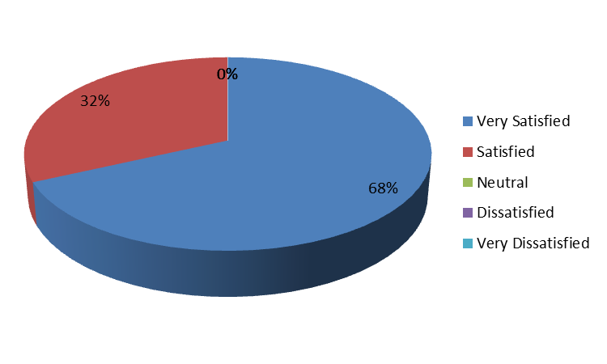

Figure 2