Project Team: El Dorado County Health and Human Services: Requests for Services and Information
HANGIN’ ON A CALL LOOKIN’ FOR A LIVE BODY

Timeline: Kaizen Event March 3-7, 2014

SOLVE
What is the Approach?
9. Team Members & Roles
10. Project Schedule
11a. Data and Information Collection
What are your Conclusions?
13. Improvement Hypotheses & Problem Solving Summary
What is the Gap?
1. Starting Point
2. Vision
3. Current State
What is the Goal for Improvement?
4. Goal or Target Condition
5. Customers & Beneficiaries
6. Benefit
7. Measures & Targets
8. Conditions

SOLVE
TRY, LEARN, INSTALL
Try Solutions; what did you learn?
14. Construct & Execute tests
15. Document Results
16. Analyze Results & Extract Learning
How will you make the new way happen?
- Plan Rollout & Execute
- Measures of Success
Understanding the Problems:
11b. Current and Future State Process Maps
12. Cause and Effect Diagram

_ SOLVE _
1. Starting Point
- What is the need (e.g. outcome) or gap that caused this project to be considered in the first place?
There is a lack of knowledge among all levels of Public Health staff about what services are offered, and by whom because of recent staff and organizational changes. We are unable to provide an efficient, consistent and seamless referral to appropriate services when the public calls.
b. Who is establishing the need?
- Anyone calling the Public Health Department
- Communicable Disease Staff

c. How is the need being measured and is it possible for this project to make an impact on that measure? and, d. What data or analysis was used to establish that this project will make a key impact?
- Customer Satisfaction Survey

e. What scope (e.g. geographic, organization, customer) are you expected to impact?
- Customers calling in (anyone external calling in or looking at website for information)
- Staff internal to the agency
- Public Health

f. What conditions are being placed on this project?
- Any significant expenditures of money need approval
- Communicate with existing teams/organization structure that are working in affected areas, e.g. web site redesign, phone installation

2. Vision (What do you want to achieve in the long range and without any restrictions? Generate a picture or description of your ideal condition. How will it look for the customers, our team, and for the taxpayers/funding sources?)
- Callers will experience easy entry and be given accurate and consistent information in the most efficient way possible. Customers will be satisfied with the experience.

3. Current State (Description of how the process and organization is operating now; Quantitative if possible, always factual and based on observation)
Stakeholder | Description | How do you know?
Customers | Get transferred multiple times often to recorded menu or number that is no longer in service. Often are unable to obtain information needed. Calls are often left unreturned. | pre test
Financial | Potential for lost clients  Time taken for staff to find appropriate information = $ | anecdotal, complaint forms
Your Team | Asked to provide good customer service without appropriate materials to do so. Results in complaints and low morale | Anecdotal

4. Goal or Target Condition (What is the objective? Which piece of the gap are you addressing?)
TO: Increase customer satisfaction when calling Public Health and increase our efficiency and effectiveness in delivering information to customers over the phone.

5. Customers and Beneficiaries (Who benefits from achieving the goal? What populations are targeted?)
- Anyone calling the Public Health Department and the 80 Public Health staff

6. Benefit (What are the benefits from achieving the goal?)
SO THAT:
- The caller is informed and able to make decisions
- The caller is able to take full advantage of services offered by the Agency
- Public recognizes value of Public Health

7. Measures and Targets (What quantitatively will be achieved?)

Beneficiaries | What Measured | How Measured | Target
 |  |  | How Much | By When | Actual
People who call Public Health | Customer satisfaction | Satisfaction with information and service given increased (for transferred calls); Survey | from 70% to 85% | 30 days after go-live | As of submission, not completed
 | Warm transfers (when information cannot be provided by initial team member) | % of calls where staff provide a warm transfer; Measured every Wed. for one month on graph in office | From 28% to 50% | June 6 | As of submission, one week was measured at 60%
 | Call response time | Frequency of calls returned (if voice mail had to be used) within one working day  Measured every Wed. for one month on graph in office | From 5% to 70% | June 6 | As of submission, one week was measured at 100 %
Reduction in labor required to route and process requests | Reduction in labor for unnecessary transfers | Frequency of calls (that required transfer to SME) completed within one transfer; Measured every Wed. for one month on graph in office | increased from 11% to 80% | June 6 | As of submission, one week was measured at 70 %
 | Reduction in labor to process calls | % of calls requiring >3 min to research and process calls  Measured every Wed. for one month on graph in office | reduced from 30% to 15% | June 6 | As of submission, one week was measured at 12 %

8. Conditions (What do you need to be successful?)
- The method/process for obtaining the information is available 24/7 to all Public Health staff that receive calls from public and has the potential to be expanded to entire Health and Human Services Agency.
- There is a process for keeping the information up to date.
- Participation each day from each team member
- Plan to identify solutions to root causes based on data
- Plan to keep stakeholders informed throughout process before, during and after solutions are installed
- There is leadership support for carrying out the process and identifying reasonable solutions

9. Team Members and Roles (Who is directly involved and How?; Training Needs?)
Name | Role | Work process related interests / concerns | Project Expectations
Heather Orchard | Supervisor for Communicable Disease Staff | Interest in staff efficiency | To decrease the amount of time staff spends on finding information for callers
Mary Hill | Animal Control office staff | Interest in routing phone calls to correct person | To increase her efficiency in answering a large volume of calls
Kristine Oase- Guth | Wild Card (Manager of preparedness and health promotions) | Genuine interest in QI in general throughout PH | Most interested in website redesign and making it easier for staff to access information
Iveeth Bannister | Answers Phones/Knows Process | Answers phone calls and would like to have an easier process to transfer | Answers a large volume of calls and is interested in having an easier way of finding information
Phyllis Houser | Preparedness staff | Answers phone calls for preparedness | Interested in creating a way to find information to answer callers questions
Alicia Paris Pombo | Health Officer | General interest in QI specifically relating to Accreditation | Improving the QI culture in PH
Nathan Robinson | Answers Phones/knows process | Interest in being able to transfer phone calls appropriately | Handles a lot of cold calls when on call. Interested in the ability to find information easily
Patti Perillo | EMS office staff | Interest in creating a phone tree to weed out calls for PH | Would like to weed out unnecessary phone calls
Melissa Cockrell | Community based nursing office staff | General interest in QI and her ability to route phone calls | Would like to cut down on unnecessary calls

10. Project Schedule (Activities to go about solving the problem)

11a. Data and Information Collection (What will you collect? Who? When?)
WHAT | WHO | WHEN
Customer survey data; collected over a two week period with a total sample size of 280 surveys. Surveys collected data on customer satisfaction, time to find information, ease of finding information, number of transfers, time to receive call back after leaving message | Public Health front end staff | Feb. 3-17, 2014
Solicited waste hunt to establish magnitude of problem | Kaizen Team | March 5, 2014

11b. Observe and Document Current Process (Generate a Process Map)

12. Conduct Cause and Effect Analysis (Priority issues and solutions from Cause and Effect Analysis)
Category | Issues/Wastes | Root Causes | Solutions or Additional CI Methods to use | Speed and Cost to Implement
Customer entry; Phone tree / website issues | Customer searching for the information (website); Website information is incomplete, out of date and not structured for quick customer use.  Customer searching for person (phone tree) that can provide the information; Incorrect selection also causes unnecessary work internally to re-route the call | Website design did not include SME input; ownership and process for content changes not clear and communicated  Functionality of phone tree not fully understood; Ownership and level of empowerment to change is unclear; Importance to customer satisfaction and impact on internal efficiency not realized; Customer and SME perspectives not fully used in the design | Change website content to get it accurate, complete and clearer for the customer within re formatting constraints  Re design, create, test, learn and install new phone trees using kaizen event working group | Minimal; team members can do within event  Minimal; use existing phone infrastructure
Transfer within Public Health; SME locator | Searching for the appropriate SME and linking them to the customer effectively and efficiently | Sources of information that customers are seeking not identified, easy to access or kept current; SME role and requirements not identified or communicated | Creation of SME (primary and secondary) look up job aid and process for keeping current | Minimal; do within kaizen event team
Process; Waste reduction and standardized work to receive, and transfer (if req’d) calls and provide answers | Rework encountered due to failure to get necessary info from customer and in transfer to SME;  Customers encounter wait and search time during transfer to subject matter expert and vmail system; phones do not always get answered or returned | No standardized work or service level agreement exists covering warm transfers (live SME) and for lukewarm transfers | Create new overall process from receipt of call to answer of information; create job aids including warm transfer and voice mail protocols, job aids (laminated scripts for receiving/transferring calls) test, learn, teach and rollout | Minimal; do within kaizen event team

13. Improvement Hypothesis (Summary of potential means to achieve goal)
Issue | Improvement | Expected Results
Labor time; Reduction in number of transfers to reach correct SME | If… we identify, make easily available and maintain a list of primary and secondary SMEs, we will reduce search time and multiple transfers caused by not reaching the appropriate source of information | Then… the labor required to process requests will be reduced; customer satisfaction will be increased
Customer satisfaction; Request for assistance call process and Warm transfers | If… we a) create and install a consistent and improved process for addressing customer requests via phone and b) include an improved process for conducting warm transfers when required to SMEs, c) establish standardized work for receiving and transferring customer information (during vmails) and d) establish an expected service level for return of calls and information | Then… customers experience will improve due to receiving correct information faster and with less difficulty
Customer satisfaction and labor reduction; Making information more readily available to customers | If…we a) identify and make key information needed by customers available on the web site and b) improve phone trees so that they are clearer and more efficient to use | Then…more customers will be able to directly find needed information; customers will be able to reach support faster when needing live support; less time will be required by team members since incorrectly routed calls will be reduced

14. Test Hypotheses (How will you test the potential solutions?)

Tests | How | Successful if…
Hard to find person to reach/transfer to; Scavenger hunt; Function test | Identify two scenarios that require SME and test with at least two people to find appropriate SME from list  Test telecommunication system functionality using new process; Does system support new process? | Both people are able to identify primary and secondary SMEs correctly  System functions correctly as designed
Phone tree hard to understand/ too long; Test new tree in English and Spanish | Ask group to listen to drafted tree to see if it is understandable, faster and gives the correct result;  Create two scenarios and see if people can reach appropriate dept/SME  Consider customer test | All scenarios result in correct dept/SME being reached  80% of people report that tree has improved speed and effectiveness
Important information is hard to find on the website; Scavenger hunt | Identify two scenarios and see if two people can find answers to shopping basket of questions | Both scenarios result in 80% of information being located with no more than 1 minute search time
Labor reduction and customer satisfaction in call answering; Standardized work run through | Test end to end new process with mock calls; Ask that two people use the process and standardized work/laminated cards in mock calls | See team measures under goal statement; Process should produce targets identified

15. Results: attach graph/table of actual trial performance

The Kaizen event team developed a quick contact sheet, a transfer protocol, a reference guide, and updated website. The team took the solutions to staff within the Public Health Department for a pilot test. The results of the test are listed below:

Website: Staff were asked to find two services using old website and then new website. The time it took to find information was reduced on average by 30 seconds using the new website.

Quick Contact Sheet: Staff were given two scenarios and were asked to find the appropriate SME from Quick Contact Sheet. Suggestions were made to include more contact information for South Lake Tahoe Staff and change wording of some of the references.

Transfer Protocol: Staff were asked to review protocol and act out actual transfers. No suggested changes were suggested.

Reference Guide: Staff were asked to use reference guide as part of the actual transfer (when acting out scenarios). Suggestions included adding a visual mark to identify side one and two.

_ LEARN _
16. Learning (For the trials, what worked and did not, why and what are you doing as a result? Is the result repeatable?)
Reasons | Learning: Why? | Direction: Actions to be taken
Website:  + Easier to find information  + Faster to find information  - some information not there | Birth 26 sec. old 8 sec. new  Pictures related to topics beneath it  Organized better  Too complex of wording | Revamping menu bar  Add burial permits  Add link in contact box  Wanted PH nursing as its own category  Make sure that the website reflects the audience
Phone tree:  - Some options not clear to customer  + no more phone tree jail | Customer looking for key words that make sense to them  Like having option to stay on line to reach live person so that they get answers to odd questions  Realized that dog and cat trap option unfamiliar | Going to use more familiar language  Explore taking out dog and cat trap option
Quick contact list:  + easy to find information  - some information missing | The way it is laid out  New perspective from outside person | Add information
Quick reference list:  + easy to use  -doesn’t reflect new map | Changed process midstream  Short easy steps | Change process map to reflect new process and then revamp reference list
Transfer policy:  -Hard to use because quick -contact list naming conventions don’t correspond to transfer policy | Separate people working on different parts of the process | Change quick contact list to correspond to transfer policy verbiage.

_ INSTALL _ 17. Installation Plan (Steps to operationalize the new process and make it stick. Attach new process map below.)

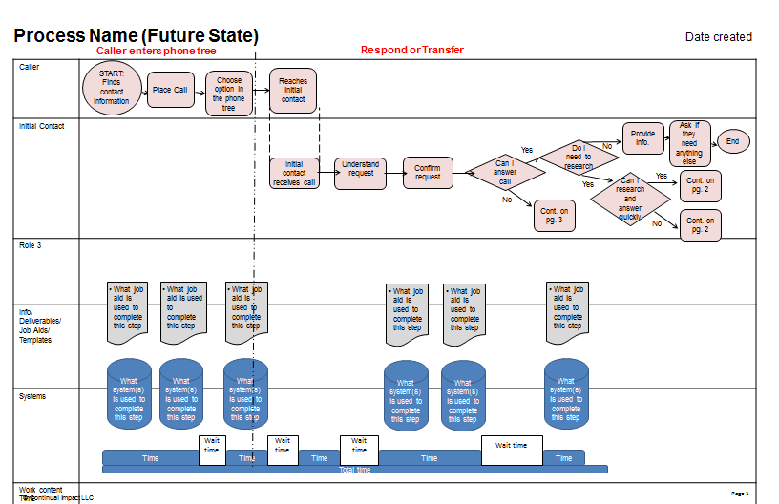

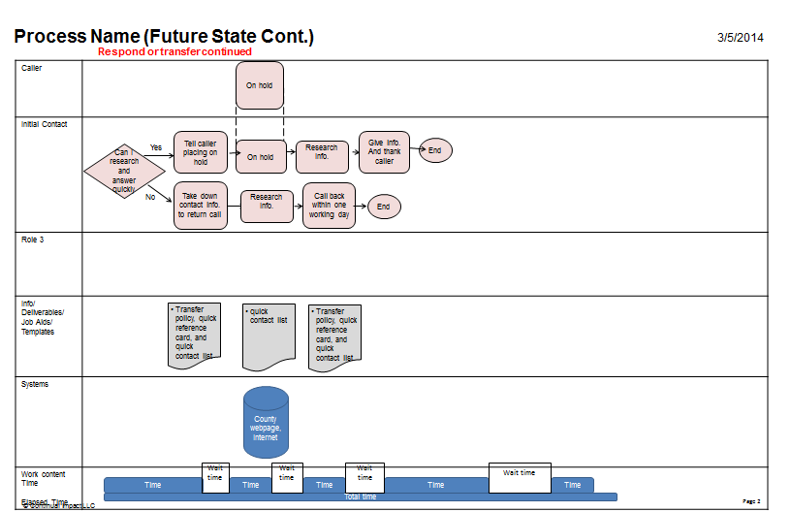
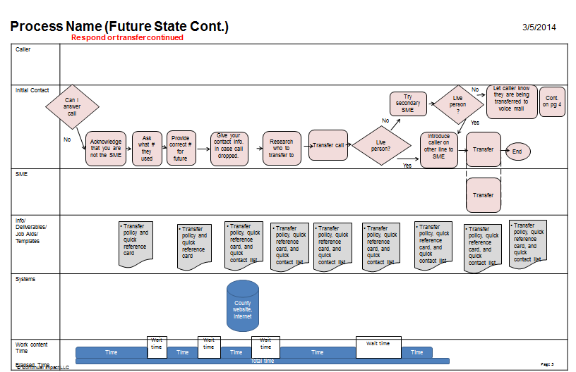

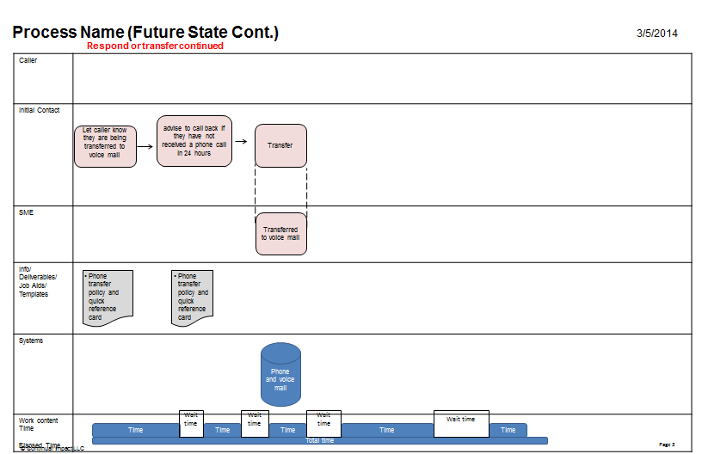

ACTION ITEMS
WHAT | WHO | DELIVERABLE | BY WHEN | STATUS
Readiness of phone tree material and installation | Alicia Paris-Pombo and Mary Hill and Patti Perillo, Heather Orchard | Complete script for Animal Services, Communicable Disease, and EMS, test, interagency phone list, and install | 15-Mar | COMPLETE
Readiness of training material Website go live | Hangin' on a call lookin' for a live body team | All standardized work processes completed | 3/15/2014 31 March for website | COMPLETE
Completion of training | Group effort: Each member of team train members of their programmatic areas on transfer policy (train the trainer) | Trained workforce in PH. All employees supplied with quick contact list, quick reference sheet, phone system, Spanish options, and transfer policy. | 31-Mar | COMPLETE
Go live | All of PH | All employees using new process | 1-Apr | COMPLETE
First team meeting | Hagnin' on a call lookin' for a live body members | Update on progress and any barriers to achieve above | 15-Mar | COMPLETE
Communication Plan | Olivia Byron-Cooper  Each Hangin' on a call member communicates to his or her section during monthly meetings | Email communicating to stakeholders after event  Addition of QI update to section monthly meetings | Week of March 8 | COMPLETE
Develop process for phone use | Hangin' on a call lookin' for a live body team | Standard process for using phones | 15-Mar | COMPLETE
Add voice mail update procedure | Hangin' on a call lookin' for a live body team | Voice Mail Policy | 15-Mar | COMPLETE
Development of traning material | Olivia Byron-Cooper and Iveeth and Mary | All employees in PH, develop training materials, train ourselves first, go to work stations, mock scenarios, until it is done correctly, at least two scenarios | 15-Mar | COMPLETE
Develop CI posters and distribute | Olivia Byron-Cooper | Get quote, purchase order, take to printers and distribute | April 1 | COMPLETE
Create Graphs for Process Measures | Olivia A. Byron-Cooper | Create template, show team, and implement | May 1 | COMPLETE
Begin Charting Process Measures on Graphs | PH Staff that answer calls | Every Wed. collect process data, compile, and chart on graphs for the month of May | May 7 | IN PROCESS

Hangin’ On A Call Lookin’ For a Live Body
CI Leadership Team Charter

Goal
To: | Provide Leadership and Support to the “Hangin’ on a call lookin’ for a live body” initiative
For: | The County of El Dorado and its PH Employees
By: | - Monitor progress and evaluate effectiveness in achieving the goal.  - Identifying problematic areas and eliminating barriers to progress that only the Leadership Team can address  - Recognizing Performance  - Identify opportunities for additional improvement
So That: | - The goals and objective of the project are achieved  - We positively impact County Employees by improving work processes and providing opportunities for personal growth.  - We kick off “Hangin’ on a call Lookin’ for a Live Body” effectively and ensure success; working on areas that are problematic and will noticeably and measurably show progress
Conditions: | - Leadership Team members time  - Support of Public Health resources  - Follow through on accountable actions  - Use available data and measures to make decisions  - Continue self-improvement skills
Standards:
 | Standard | Measure | Target
 | Continuous and consistent engagement of team | - Attendance at each meeting  - Participation in decision making | - 80%  - 100%
 | Buy in regarding Quality improvement processes  Outside participation by non-team members on our fish bone diagrams  Implemented ideas created by fish bone to our process | - Application of quality improvement tools to other projects  - Each section participates in process (West and East slope)  Implemented Ideas generated on fish bone diagram | - Average of 2 per month  - 100% participation  - Average of 2 per month

Team Responsibilities
- Monitor progress to achieving the goal (see above) and elevate team performance as needed.
- Identify and remove barriers that interfere with achieving the team's goal.

- Identify and utilize opportunities to teach, promote, and install a Continuous Improvement organization.

Connections
- All PH employees
- Public
- CI Champions (Hangin’ on a call lookin’ for a live Body members)
- Stakeholders

Procedures

Meeting: | - 2X per month for 1 hour  - Commitment of members to attend all meetings as best as possible.
Agenda: | - Review previous meeting’s scheduled actions, CI events  - Identify any problematic areas or issues  - Identify barriers to progress and take actions  - Review opportunities to recognize Performance  - Identify opportunities for additional improvement and prioritize  - Establish Next meeting’s key events
Work Process: | - Check progress  - Root Cause issues  - Prioritize and Decision making  - Plan Actions
“Red-Faced Tests” | - Achievement based on performance to standards.  - Full participation of all team members.

The Continual Improvement System poster is the way we are continuing to track progress, issues and ideas. There is one posted in each place of work and staff have been encouraged to document any issues, suggestions, or concerns. Every Friday we meet to discuss what has been posted, identify potential solutions to the issues, and assign a lead person to develop and implement the identified solutions. This enables us to continue to improve.

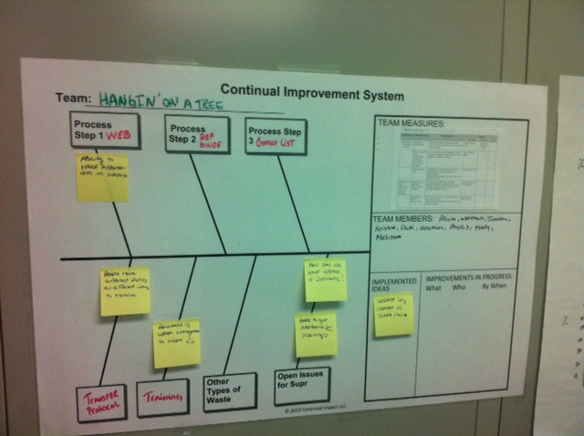

18. Measure Success attach graph/table of installed performance

 | Before Kaizen | Goal | May 7 | May 14 | May 21 | May 28
% Warm Transfers | 28% | 50% | 60% | 65% | 62%
% calls returned in 1 day | 5% | 70% | 100% | 95% | 98%
% with 1 Transfer | 11% | 80% | 70% | 72% | 73%
% requiring > 3 minutes | 30% | 15% | 12% | 11% | 12%

