QRG

OMC REFERRAL WORKQUEUE WORK FLOW

- Click the Epic button and select Referrals > Workqueue List
  - Once you have opened up a menu item, you can create Menu Favorites.
    - To create Menu Favorites, under Recent, click on the STAR next to Workqueue List. Favorites will now appear at the top of your EPIC drop down menu
- Double click on the SA 14 NURSE HOME VISITING group
- Sort referrals by Status, Referral Type, or Assigned To by clicking on column header (See Appendix A if this is the first time in the Workque to standardize columns)
- Clicked on the Defer column where all New Prenatal Screening clients will be placed prior to being called.
  - You will need to sort in the Deferred column as well if this is your first time.
- Click once on referral to see detail (preview pane, bottom of screen)
- Click on arrow next to Assign To User, then Assign to Self (or other User)
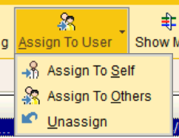
Referral Types Legend
New Prenatal Screening ----> Need to see OMC staff
PN (prenatal) ----> Seen by OMC staff, NHV to contact if unassigned
Babies First ----> NHV to contact if unassigned
CaCoon ----> NHV to contact if unassigned
Care Coordination ----> NHV to contact if unassigned

NOTE: Click once on referral to see detail (preview pane, bottom of screen) and to Assign to User. Double click to update referral information
PREGNANCY
INITIAL contact/attempt

Double click on referral to update record. The Referral Entry General screen will now display

General
- Change Status to Open (if not already)
- Make sure Class is set to Incoming
- Click Next (or choose Open Reason from the menu to the left hand side of your screen)

Dx/Px
- Enter EDC MM/DD/YY in free text Diagnosis cell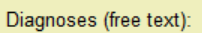 if not already completed
- Enter Place of Service (initials), Dr. Name in free text Procedures cell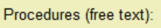 if not already completed
- Click on Notes from the menu to the left hand side of your screen

Notes
- Create new note by clicking New in the Notes tab
  - Choose Referral Entry Comment for the Type
  - Free text notes or use smart phrase .SA14MCHREFFERALINFO
  - Type Initial in the Summary section
  - Click Accept Note
  - Click Accept (bottom right of screen)

FOLLOW-UP contact/attempt

Double click on referral to update record. The Referral Entry General screen will now display

Notes
- Create new note by clicking New in the Notes tab
  - Choose Referral Entry Comment for the Type
  - Free text notes section
  - Type Follow up in the Summary section
  - Click Accept Note
  - Click Accept (bottom right of screen)

IF DURING A FOLLOW UP OR INITIAL CALL Client has accepted NHV visit
- Change Ref Type to PN
- Follow above instructions for all other updating

CLOSE REFERRAL
REFERRAL NOT CONTACTED
General
- Change Status to Denied
- Change Status Reason to Forwarded to Healthy Families or Due to Capacity Limits
- Click on Notes from the menu to the left hand side of your screen

Notes
- Create new note by clicking New in the Notes tab
  - Choose GENERAL for the Type (this is the ONLY note type that will print in the Referral printout-no other notes will be included)
  - Type free text or use smart phrase .SA14MCHREFERRALNOTE in the notes section
  - Type Final in the Summary section
  - Click Accept Note
  - Click Accept (bottom right of screen)
Letters
- Use OCHIN letter template SA14 MCH OUTCOME RESPONSE letter to fax referral outcome to referring provider as needed.

Client NOT engaged in NHV services, no initial visit
General
- Change Status to Closed
- Change Status Reason to Phone Contact Refused Service, No contact, or Unable to Locate
- Click on Notes from the menu to the left hand side of your screen

Notes
- Create new note by clicking New in the Notes tab
  - Choose GENERAL for the Type (this is the ONLY note type that will print in the Referral printout-no other notes will be included)
  - Type free text or use smart phrase .SA14MCHREFERRALNOTE in the notes section
  - Type Final in the Summary section
  - Click Accept Note
  - Click Accept (bottom right of screen)
    - Fax/send print out to referral source (the ability to fax through RightFax is in process)
Letters
- Use OCHIN letter template SA14 MCH OUTCOME RESPONSE letter to fax referral outcome to referring provider as needed.

FIND CLOSED REFERRALS
- Click the Epic button and select Referrals > Referral Entry
- Click on Custom Search tab
- Type in Search parameters
- Click Search

Appendix A

In the Workque click on Column Action
Then click on Column to standardize Workque columns
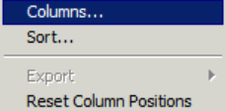
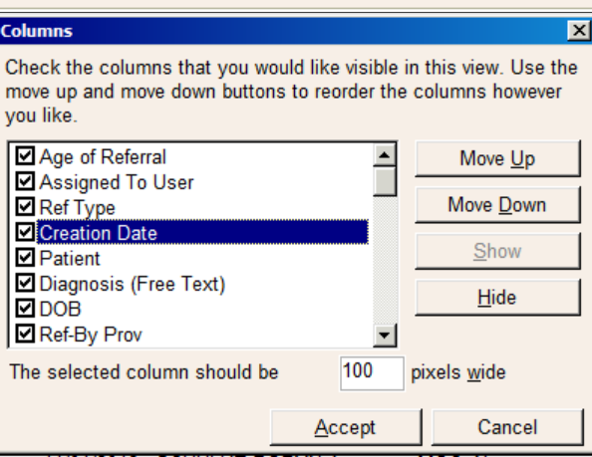
Delete all items not listed below by unchecking the box. Move up or move down to order Column by using the Move Up and Move Down buttons

The list should be as follows…

- Age of Referral
- Assigned to User
- Ref Type
- Creation Date
- Patient
- Diagnosis (Free Text)
- DOB
- Ref-By-Pro
- Age: Years
- Procedure (Free Text)
- Plan Name
- PCP
- Language
- Note?

