Cobb & Douglas Public Health
Quality Improvement Project Worksheet

Purpose:
The purpose of this worksheet is to describe the specific steps of the Plan-Do-Study-Act (PDSA) cycle. PDSA, sometimes referred to as Plan –Do-Check-Act (PDCA) is one method of Quality Improvement (QI). The worksheet may be used to outline future plans and/or record progress once steps are completed. QI project teams should also attach data collection tools (populated with data) to track and measure progress towards achieving the QI AIM Statement.
PDSA Overview:
The Plan-Do-Study-Act (synonymously referred to as Plan-Do-Check-Act) cycle provides a framework for standardizing a quality improvement project. It provides a simple, iterative (cyclical) approach to identifying, defining, and launching a quality improvement project. The plan-do-check-act cycle was made popular by Dr. W. Edwards Deming, who is considered to be the father of modern quality control. PDSA should be repeatedly implemented in an effort to get closer to excellence with each cycle.
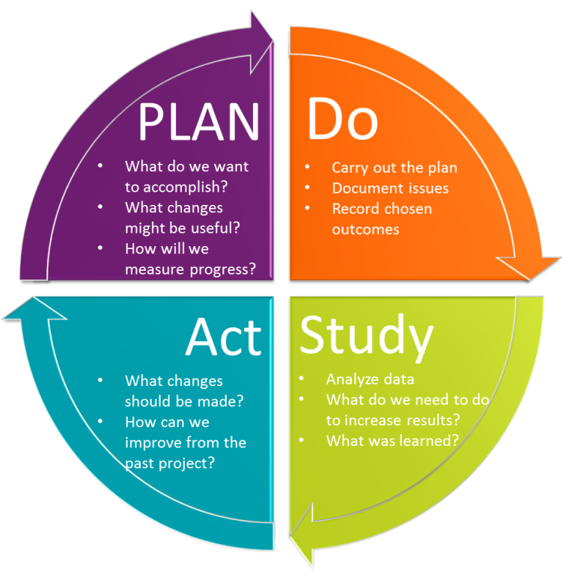
Instructions: Check-off items once complete. Add notes in the far right column.
Plan, Do, Study, Act (PDSA) Cycle
PLAN | Identify an Opportunity for Improvement
- Identify area, problem, or opportunity for improvement
- Estimate and commit needed resources
- Obtain approval (if needed) to conduct QI
- Need Help? Look for QI opportunities by reviewing low scoring Balanced Scorecard metrics, budget and/or billing reports, or federal/state reports (including audits).
 | Assemble the Team (based on the process map)
 | - Identify and assemble team members (including customers and/or stakeholders) that play a part in the process  - Identify team member roles & responsibilities  - Establish initial timeline for improvement activity and schedule regular team meetings  Need Help? Here’s a QI Team Charter. (not required to complete) | Key Members | Role/Responsibilities
 |  | Mtg Frequency:
 |  | Mtg Duration:
 | Step 1: Develop Aim Statement/SMART Goal
- Develop an AIM Statement or SMART Goal for your project (Specific, Measureable, Achievable, Relevant, Time-Bound). Try to keep the focus narrow so that you are not measuring multiple things at the same time and can establish a cause-and-effect relationship between your theory, intervention, and the result.
Need Help? See the AIM Statement Worksheet to formulate SMART goals. Brainstorm. Ask the team,
- What are we trying to accomplish? What are we doing now? How do we do it?
- What are the major steps in the process?
- Who is involved? What do they do?
- What is done well? What could be done better?
 | Step 2: Examine the Current Approach
 | - Examine the current approach by constructing a swim lane map or a process/flow chart to visually describe steps in the current process.  - Obtain input from customers and/or stakeholders  Need Help? At this stage, you will want to select tools from your QI Toolbox. You may consider using a fishbone or cause and effect diagram to brainstorm potential solutions. Selecting the right QI tool is important. Have you ever tried to eat spaghetti without a fork, or steak without a knife? Take some time to view additional tools, such as, bar, pie, pareto, and other charts or graphs to visualize data | Insert Process Map
 | Step 3: Gather Baseline Data
- Obtain existing baseline data (when possible).
  - Data = information (ex: wait times, number of patients, satisfaction levels, etc)
- Revise Aim Statement based on baseline data as needed
 | Step 4: Identify Potential Solutions
- Determine root cause(s) of the problem.
- Identify all potential solutions to address the root cause(s)
- Review model or best practices to identify potential improvements, consider conducting a search of the NACCHO Model Practices Database, or PHQIX projects for examples from other health departments. (If these don’t fit, develop your own.)
- Focus on solutions which we have some control
 | Step 5: Develop an Improvement Theory
- Develop a theory for improvement-What is your prediction?
- Use an “If . . . . Then” approach
Ex: IF we decrease patient wat times, THEN we will have more time for administrative tasks.

DO | Step 6: Test the Theory
 | - Carry out the test.
 | Step 7: Collect and Document the Data
- Collect, chart, and display data to determine effectiveness of the test.
  - Remember data = information (ex: wait times, number of patients, satisfaction levels, etc)
- Document problems, unexpected observations, and unintended side effects.
STUDY | Step 8: Study the Results
- Determine if your test was successful:
  - Compare results against baseline data and the measures of success stated in the Aim Statement
  - Did the results match the theory/prediction?
  - Did you have unintended side effects or unintended observations?
  - Do you have enough data to achieve your AIM statement?
ACT | Step 9: Establish Future Plans
- Adopt, Adapt, or Abandon your project
  - Adopt: If your improvement was successful on a small scale, adopt it and test it on a wider scale.
  - Adapt: If your improvement was partially successful, but there is room for improvement, adapt it and test again until the AIM statement is achieved.
  - Abandon: If your change was not successful (no improvement was seen), develop a new theory and test it; often several cycles are needed to produce the desired improvement
- Communicate your accomplishments to others through the storyboard (poster) (next page).

Team Members:
List team member names here
QI Project Storyboard
[Insert Project Title]
1. Aim Statement
Start typing here

2. Examine the Current Approach

(INSERT OR ATTACH PROCESS MAP)

3. Baseline Data
Start typing here

4. Identify Potential Solutions
Start typing here

5. Develop an Improvement Theory
IF ….., THEN …..
8. Study the Results
Start typing here
9. Establish Future Plans: (ADOPT, ADAPT, OR ABANDON)
Start typing here
ACT
Standardize the Improvement & Establish Future Plans
STUDY
Use Data to Study Results of the Test
6. Test the Theory
Start typing here

7. Collect and Document Data
Insert charts or graphs or other visual depictions of data.
ACT
Standardize the Improvement and
Establish Future Plans
DO
Test the Theory for Improvement
PLAN
Identify an Opportunity & Plan for Improvement

