Deschutes County Health Services (DCHS) continues to focus and improve our efforts to develop a robust and functioning performance management system, and plans to continue to support and improve the integrated management system (IMS) moving forward. This system aligns plans and action both internally, among programs, divisions, and the agency, and externally to regional, state, and federal priorities. The Images below help describe how the IMS and plans align.

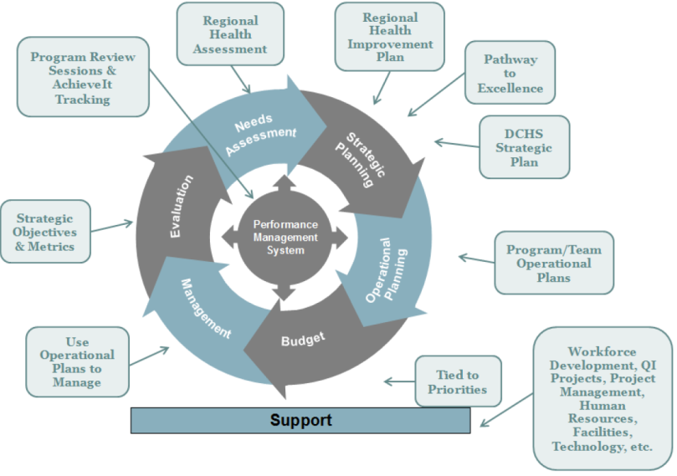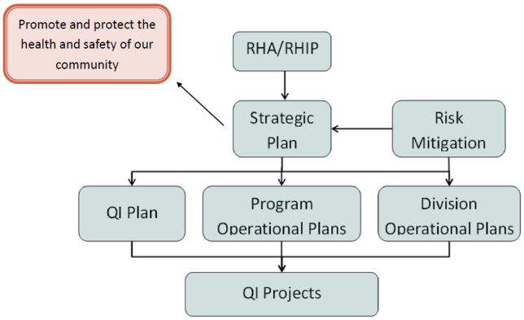

DCHS updated the QI plan to better incorporate the integrated management system. The plan specifies that DCHS will refer to the following when determining quality improvement priorities:
- Strategic Plan: The DCHS Strategic Plan objectives and goals will be considered when determining priorities for quality improvement efforts.
- Public Health Accreditation Evaluation: The leadership team and public health accreditation coordinator will evaluate the capacity to meet the standards, measures, and documentation requirements and prioritize deficiencies as quality improvement initiatives.
- Operational Plan Reviews: Programs will report on metrics and action items in their operational plan. When extra support is requested or determined, quality improvement initiatives will be considered.
- QI Culture Self-Assessment: DCHS will complete a QI Culture Self-Assessment to determine where DCHS lies on the QI culture roadmap. Results will be presented to the public health and behavioral health quality councils. Where extra support is needed, quality improvement initiatives will be considered.
- Post Incident Debriefs: Debrief reports related to health events will be reviewed. Where extra support is needed, quality improvement initiatives will be considered.
- Customer Service: Through client and customer satisfaction surveys and/or other methods, DCHS will determine (internal and external) client needs for services and/or improvement of care delivery. This includes staff reporting QI needs for their program/ service area. A client satisfaction survey will be assessed twice annually for public health and behavioral health programs and services.
- HIPAA Compliance Findings: The Public Health Registered Health Information Technician will inform the Quality Council of issues regarding HIPAA policies, training, confidentiality, potential confidentiality breaches, data sharing, security, and retention policies.
- Deschutes County Internal Audit Findings: Audits and reports from DCHS audits regarding business functions will be reviewed and updated to report on compliance with suggested changes. Where extra support is needed quality improvement initiatives will be considered.

DCHS has established a system performance program that will continue to modify and improve the quality improvement (QI) program and process.

